**AOI System – Operator Manual**

**Version: 1.0  
Intended Audience: Operators**

## INDEX

1. Introduction

# Purpose of the AOI System

# Intended Users

* 1. System Overview
  2. Operator Responsibilities

2. Document Scope & Intended Audience

3 Login Screen

System Overview

Login Screen and User Access

Dashboard Screen Overview

OEE Monitoring and Performance Screens  
    5.1 OEE Dashboard  
    5.2 Efficiency Breakdown  
    5.3 Production Statistics

Time Synchronization (Time Sync)

Alarm Monitoring Screen

Logs and System Records  
    8.1 Audit Logs  
    8.2 Production Logs  
    8.3 Error Logs  
    8.4 Diagnostic Logs

Reports and Data Export

Mode of Operation  
    10.1 Auto Run Mode  
    10.2 Dry Run Mode  
    10.3 Manual Mode  
    10.4 Cycle Stop  
    10.5 Machine Home

Manual Operation Panel

Configuration Menu (Config)  
    12.1 Log Configuration  
    12.2 Device Configuration  
    12.3 Alarm Configuration  
    12.4 User Configuration  
    12.5 PLC Tag Configuration  
    12.6 Report Configuration

External Interface Configuration

Operator Responsibilities

Safety and Usage Guidelines

# **1. Introduction**

The **AOI System (Automated Optical Inspection System)** is an industrial inspection application designed to **automatically monitor, inspect, and evaluate product quality** during the production process.

The system integrates with **machine vision cameras, PLC controllers, and industrial hardware** to perform real-time inspection and collect production data. It helps Operators and Supervisors ensure that every product meets defined quality standards before moving to the next process stage.

The AOI System provides a centralized platform to:

* Monitor inspection performance
* Track production and quality statistics
* Detect and display alarms and system faults
* Maintain system and production logs
* Generate reports for analysis and traceability

This application is primarily intended for **shop-floor Operators** who are responsible for running and monitoring the inspection process.

# **1.1 Purpose of the AOI System**

The main purpose of the AOI System is to:

* Detect product defects automatically using vision-based inspection
* Reduce manual inspection effort and human error
* Improve production efficiency and consistency
* Provide accurate and traceable production records
* Support continuous quality improvement

By using automated inspection, the system ensures **higher accuracy, faster inspection cycles, and reliable quality control** compared to manual methods.

# **Intended Users**

This Operator Manual is prepared for the following users:

**Operators:**  
Responsible for daily operation, monitoring, and basic control of the AOI System.

* **Supervisors / Quality Staff (View Only):**  
  May use reports and logs for performance analysis and quality tracking.

System configuration and advanced settings are handled by **authorized administrative users** and are not part of routine operator activities.

# **1.3 System Overview**

The AOI System consists of the following main functional areas:

1. **Login and User Authentication**  
   Ensures only authorized users can access the system.
2. **Dashboard and OEE Monitoring**  
   Displays real-time inspection performance, production counts, efficiency, and machine status.
3. **Alarm Monitoring and Logs**  
   Shows system faults, inspection errors, and operational events for troubleshooting and traceability.
4. **Reports and Data Export**  
   Allows Operators to view and export production and quality data in standard formats such as CSV.
5. **Mode of Operation and Manual Control**  
   Provides options for Auto Run, Dry Run, Manual Mode, Cycle Stop, and Machine Homing.
6. **Configuration and External Interface**  
   Enables setup of report formats, devices, alarms, PLC tags, and data interfaces.

# **1.4 Operator Responsibilities**

Operators using the AOI System are expected to:

* Monitor inspection status during production
* Respond to alarms and abnormal conditions
* Follow standard operating procedures during manual operation
* Maintain accurate production records using system logs and reports
* Report system issues to maintenance or administration teams

Proper usage of the AOI System helps ensure **safe, efficient, and high-quality production**.

**2 Document Scope & Intended Audience**

This document is prepared primarily for **Operators** who work on the AOI System in a shop-floor environment.  
The content is written in a clear, practical, and step-by-step manner to support **daily machine operation, monitoring, and reporting activities**.

The explanations strictly follow the **actual system screens, workflow, and operating sequence** used on the production floor.  
All screenshots, labels, and terminology match the live AOI System interface to avoid confusion during operation.

While the system also supports **Administrator-level functions**, this document focuses on **Operator usage only**, except where Admin-related actions are necessary for understanding system behavior.

The objective of this document is to:

* Help Operators quickly understand system usage
* Ensure safe and correct operation of the AOI System
* Maintain consistency between documentation and real-time system behavior

### **Usage Note**

This document should be used as a **reference guide during machine operation**.  
Operators are advised to follow the instructions exactly as described and **avoid performing actions outside their assigned role**.

For configuration changes, system access issues, or abnormal behavior, Operators should always contact the **System Administrator or Maintenance team**.

**3 Login Screen**

**3.1 Purpose**

The **Login Screen** is the first screen displayed when the AOI System application starts.  
It is used to verify the identity of the user and allow secure access to the system.

Only **authorized Operators and Administrators** can log in using valid credentials.

## 3.2 User Roles

The AOI System supports two types of users:

### **Operator**

* **User Type:** Operator
* Operators use the system for day-to-day machine operation, inspection, monitoring, and report viewing.
* Operators have access only to operational features assigned to their role.

### **Administrator**

* **User Type:** Admin
* Administrators manage system configuration, users, alarms, devices, PLC tags, and reports.
* Admin users have higher-level access compared to Operators.
* Access to system features depends on the logged-in user role.

**3.3 Screen Overview**

The **Login Screen** includes the following items:

### **System Name**

* Displays the application name **AOI System**.

### **Username Field**

* Used to enter the assigned username for the Operator or Administrator.

### **Password Field**

* Used to enter the corresponding password.
* The password is masked for security purposes.

### **Login Button**

* Used to submit login credentials and access the system.

**3.4 Login Steps**

To log in, follow these steps:

1. Open the **AOI System** application.
2. Enter the username in the **Username** field.
3. Enter the password in the **Password** field.
4. Click the **Login** button.
5. If the credentials are correct:
   * Operators are redirected to the **Operator Dashboard**.
   * Administrators are redirected to the **Admin Dashboard**.

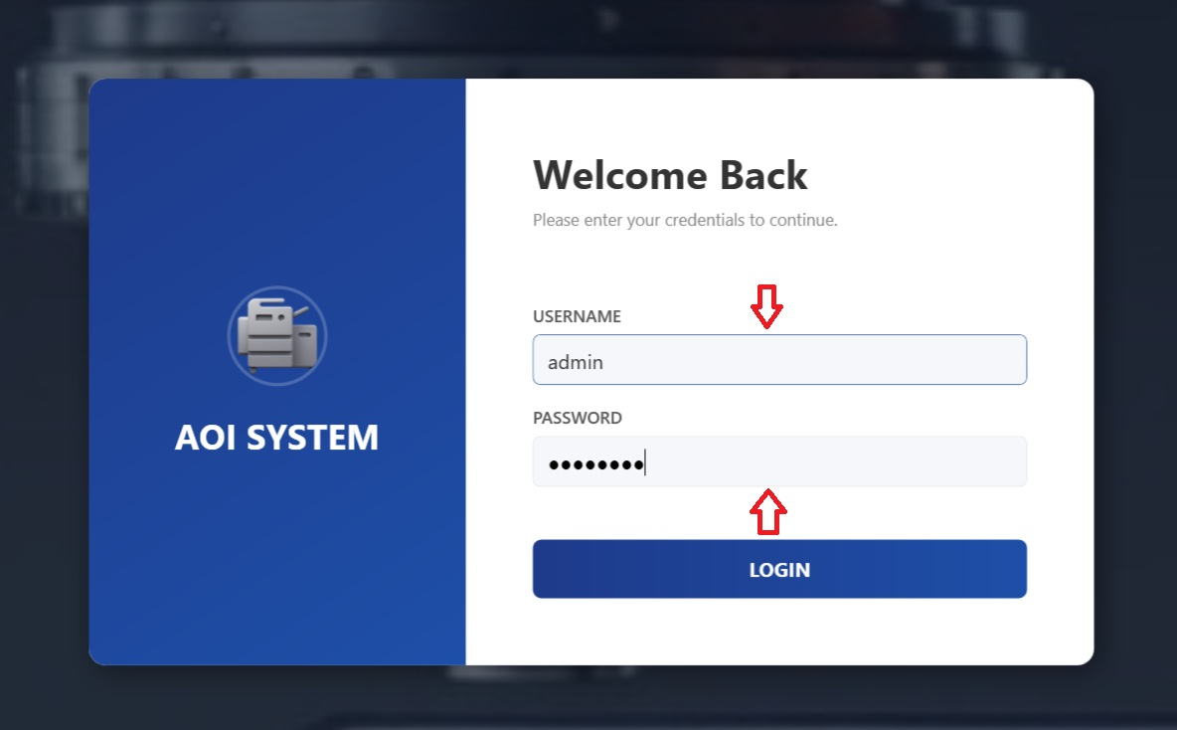

## 3.5 System Response

### **Successful Login**

* The system validates the credentials.
* Access is granted based on the user role.
* The appropriate dashboard is displayed.
* Authorized features become available.

Login Failure

If the username or password is incorrect:

* An error message is displayed.
* Access is denied.
* The user must re-enter correct credentials.

**3.6 Security Guidelines**

Username is **case-insensitive**.

Password is **case-sensitive**.

Users must keep login credentials confidential.

Multiple incorrect login attempts may temporarily block access.

For login-related issues, contact the **System Administrator**.

**3.7 User Responsibility**

**Operator Responsibility**

* Do not share login credentials.
* Log out after completing work.
* Report any access issues to the administrator.

### **Administrator Responsibilities**

* Manage user accounts responsibly.
* Ensure only authorized users have access.
* Monitor login issues and resolve access problems.

### **Dashboard Screen (Post Login)**

## 4.1 Screen Name

**Operator Dashboard / Home Screen**

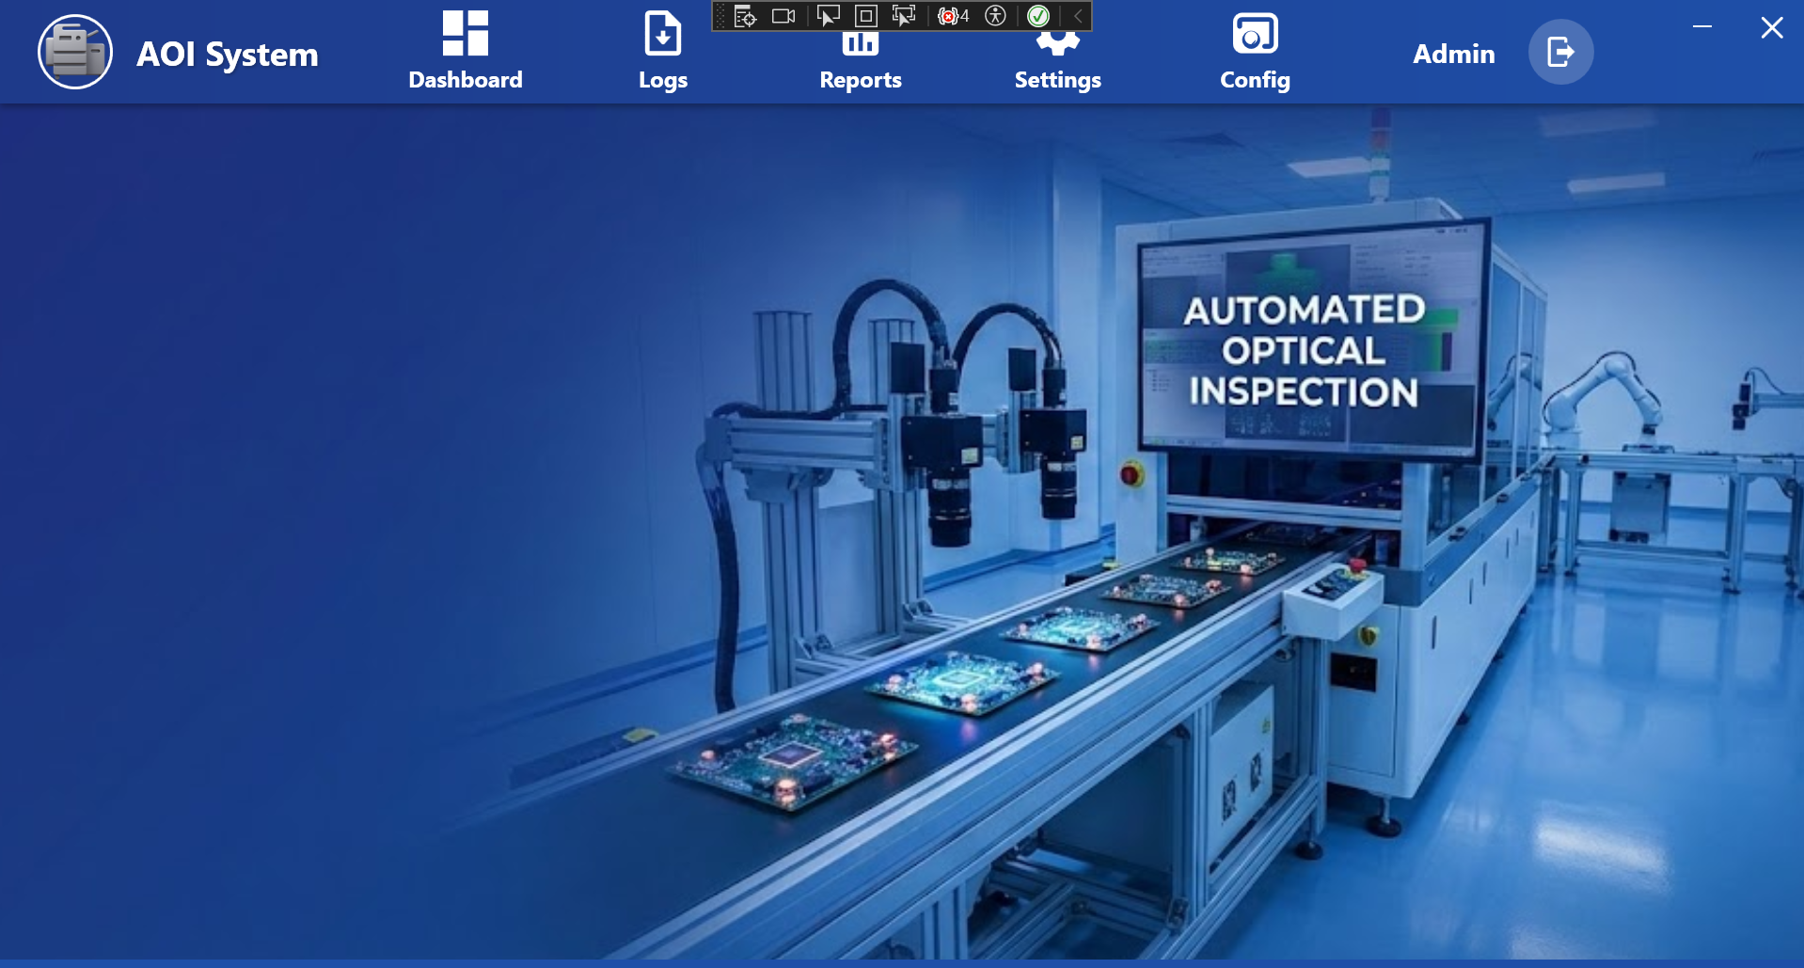

**4.2 Purpose of the Screen**

The Dashboard Screen is displayed after a successful login.  
It is the **main working screen** for the Operator.

From this screen, the Operator can:

* Monitor system status
* Access logs and reports
* Check machine connectivity
* Navigate to assigned modules

**4.3 Screen Overview**

The Dashboard screen contains the following main areas:

**4.4 Top Navigation Bar**

The top bar provides quick access to important sections of the system:

* **Dashboard**  
  Returns to the main dashboard view.
* **Logs**  
  Used to view system and operation logs.
* **Reports**  
  Used to view inspection and performance reports.
* **Settings**  
  Used to view system settings (limited access for Operator).
* **Config**  
  Used for configuration-related options (access depends on permission).
* **User Info / Logout**  
  Displays the logged-in user and provides logout option.

**4.5 Main Display Area**

The center area of the dashboard shows the **AOI machine working environment**.

This visual represents:

• Automated Optical Inspection process

• Boards or components under inspection

• Current operational state of the system

This helps the Operator quickly understand whether the system is active and running.

**4.6 System Status Information**

At the bottom of the screen, system status messages are displayed.

### Example Status Indicators:

* **PLC Connection Status**  
  Shows whether the PLC is connected or disconnected.
* **System Version**  
  Displays the current software version.
* **Date and Time**  
  Shows the current system date and time.

These indicators help the Operator identify system health at a glance.

**4.7 Operator Actions from Dashboard**

From the Dashboard screen, the Operator can:

• Monitor system connectivity

• Navigate to Logs for issue tracking

• View Reports for inspection results

• Check system status messages

• Log out after completing work

**4.8 Operator Limitations**

• The Operator cannot change critical system configurations.

• Advanced settings are restricted to Admin users.

• Access depends on assigned permissions.

**5 Dashboard – Menu View**

## 5.1 Screen Name

**Dashboard – Menu Screen**

**5.2 Purpose of the Screen**

This screen is displayed when the Operator clicks on the **Dashboard** option.  
It provides access to key operational views required for daily monitoring and control.

This screen helps the Operator quickly navigate to important system functions.

**5.3 Screen Layout Overview**

The screen is divided into two main sections:

* **Left Menu Panel**
* **Main Display Area**

**5.4 Left Menu Panel (Operator View)**

The left-side menu provides navigation to important Operator functions.

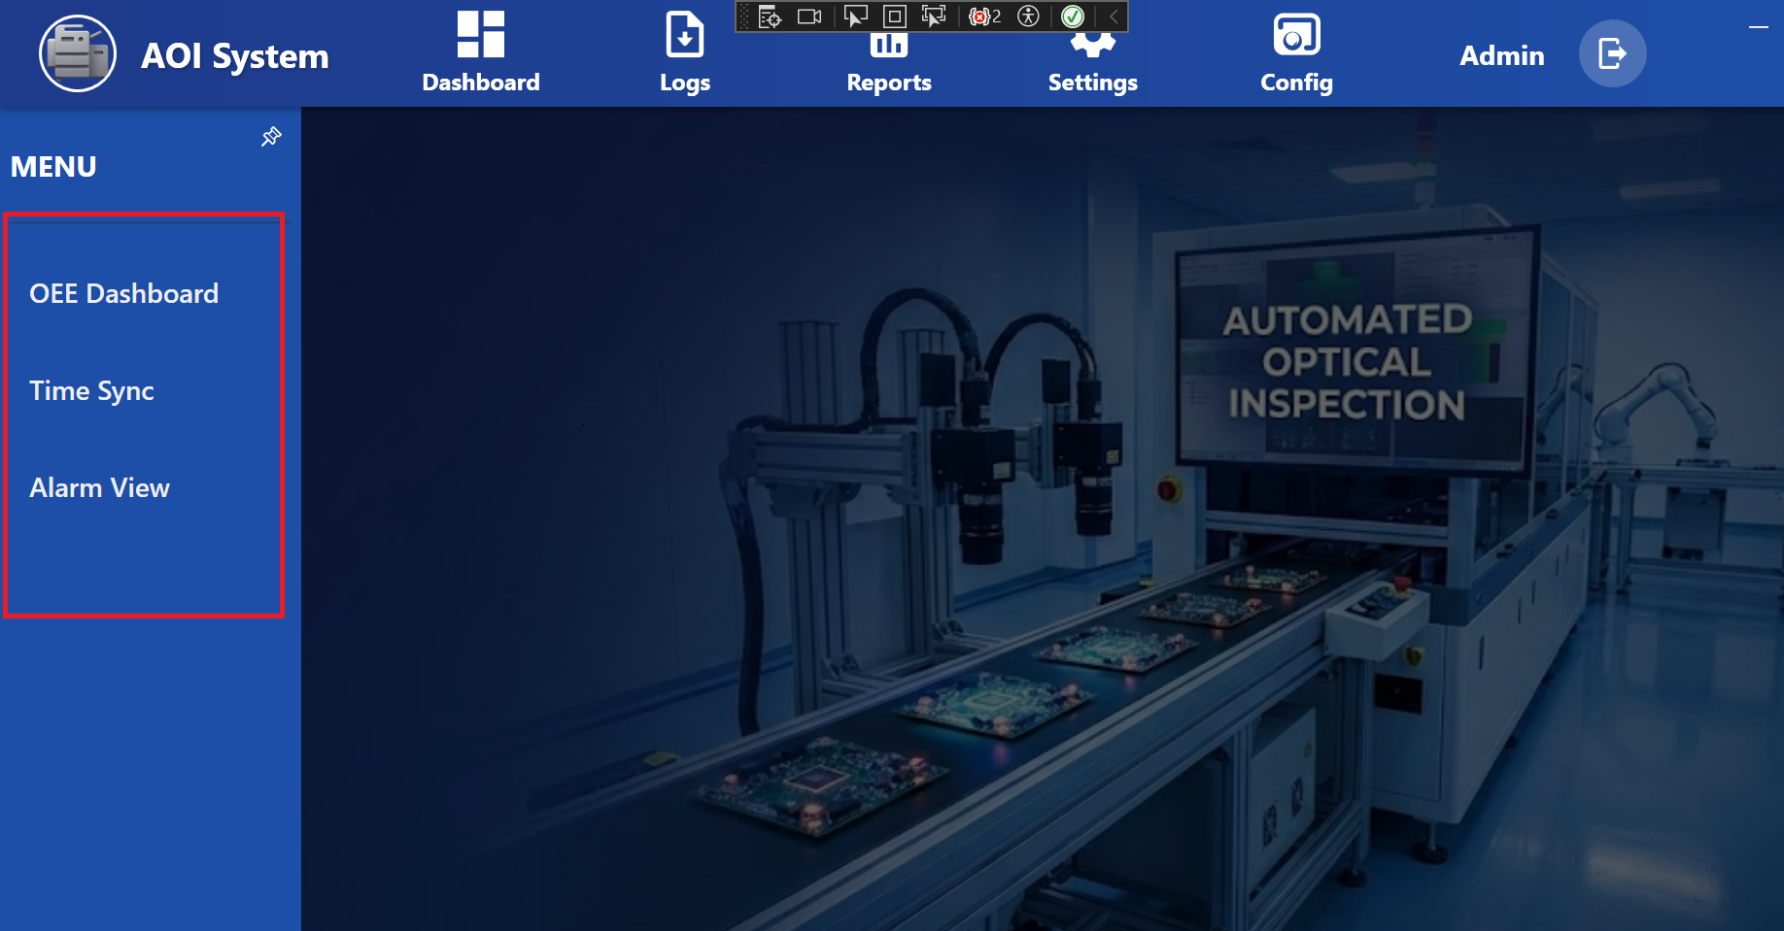

**5.5 OEE Dashboard**

• Displays Overall Equipment Effectiveness (OEE) information.

• Used to monitor machine performance and productivity.

### **5.6 Time Sync**

* Used to synchronize system time.
* Ensures correct timestamps for logs and reports.

### **5.7 Alarm View**

* Displays active and historical alarms.
* Helps the Operator identify and respond to system issues.

**5.8 Main Display Area**

The main area shows the **current operational view** selected from the menu.

Depending on the selected option:

* OEE data
* Time synchronization status
* Alarm details

will be displayed in this area.

**5.9 Operator Actions**

From this screen, the Operator can:

* Open the OEE Dashboard to check performance
* Verify or sync system time
* View alarms and system warnings
* Monitor system condition during operation

**5.10 Operator Access Limitations**

* The Operator can view information but cannot change critical configurations.
* Advanced system settings are restricted to Admin users.
* Access is based on assigned permissions.

**5.11 Important Notes for Operator**

* Regularly check the **Alarm View** for any active issues.
* Ensure system time is correct before starting operations.
* Report repeated alarms to the supervisor or administrator.

### **6 OEE Inspection Dashboard**

## 6.1 Screen Name

**OEE Inspection Dashboard**

**6.2 Purpose of the Screen**

The OEE Inspection Dashboard is used to **monitor machine performance and inspection status in real time**.  
It provides key operational metrics required by the Operator during daily production.

This screen helps the Operator understand:

* Machine running time and downtime
* Inspection performance
* Quality results

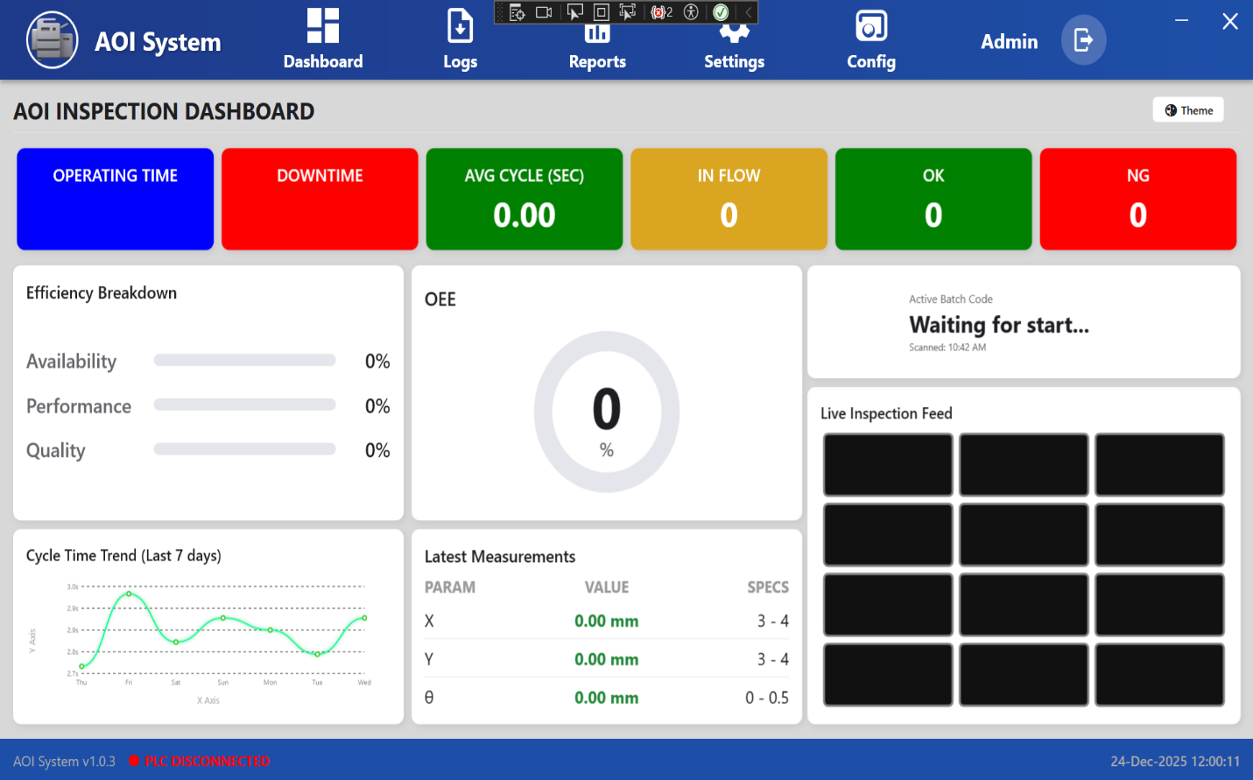

**6.3 Top Performance Indicators**

The top section displays key performance values:

* **Operating Time**  
  Shows the total time the machine has been running.
* **Downtime**  
  Shows the total time the machine was stopped or inactive.
* **Average Cycle Time (Sec)**  
  Displays the average inspection cycle time in seconds.
* **In Flow**  
  Shows the number of boards/components currently under inspection.
* **OK**  
  Displays the count of passed inspections.
* **NG**  
  Displays the count of failed inspections.

**6.4 Efficiency Breakdown Panel**

This section shows efficiency details in percentage:

* **Availability**  
  Indicates how much time the machine was available for operation.
* **Performance**  
  Indicates how efficiently the machine is running compared to expected speed.
* **Quality**  
  Indicates the percentage of good (OK) inspections.

**6.5 OEE Indicator**

* Displays the **Overall Equipment Effectiveness (OEE)** value in percentage.
* Combines Availability, Performance, and Quality into a single metric.
* Helps the Operator quickly assess overall system efficiency.

## 6.6 Active Batch Information

* Displays the **current batch status**.
* Example: “Waiting for start” indicates inspection has not yet started.
* Shows the last scanned time for the batch.

## 6.7 Live Inspection Feed

* Displays live camera images from the inspection process.
* Allows the Operator to visually monitor ongoing inspections.
* Black or empty frames indicate that no inspection is currently active.

## 6.8 Cycle Time Trend (Last 7 Days)

* Shows a graphical trend of inspection cycle time.
* Helps identify performance variations over time.
* Useful for monitoring consistency.

## 6.9 Latest Measurements Panel

Displays the most recent measurement values:

* **Parameter Name** (X, Y, θ, etc.)
* **Measured Value**
* **Specification Range**

Helps the Operator verify whether measurements are within limits.

**6.10 System Status Information**

At the bottom of the screen:

* **System Version** is displayed
* **PLC Connection Status** is shown
  + Example: *PLC Disconnected*
* **Date and Time** are displayed

## 6.11 Operator Actions

From the OEE Dashboard, the Operator can:

* Monitor inspection performance
* Track OK and NG counts
* Observe live inspection feed
* Identify downtime or connection issues
* Inform supervisor in case of abnormal values

## 6.12 Important Notes for Operator

* Always check **PLC connection status** before starting inspection.
* If OEE or efficiency values remain zero, verify system readiness.
* Report repeated NG results or alarms immediately.

### **7** **Operating Time – Detail View**

## 7.1 Screen Name

**Operating Time – Detail View**

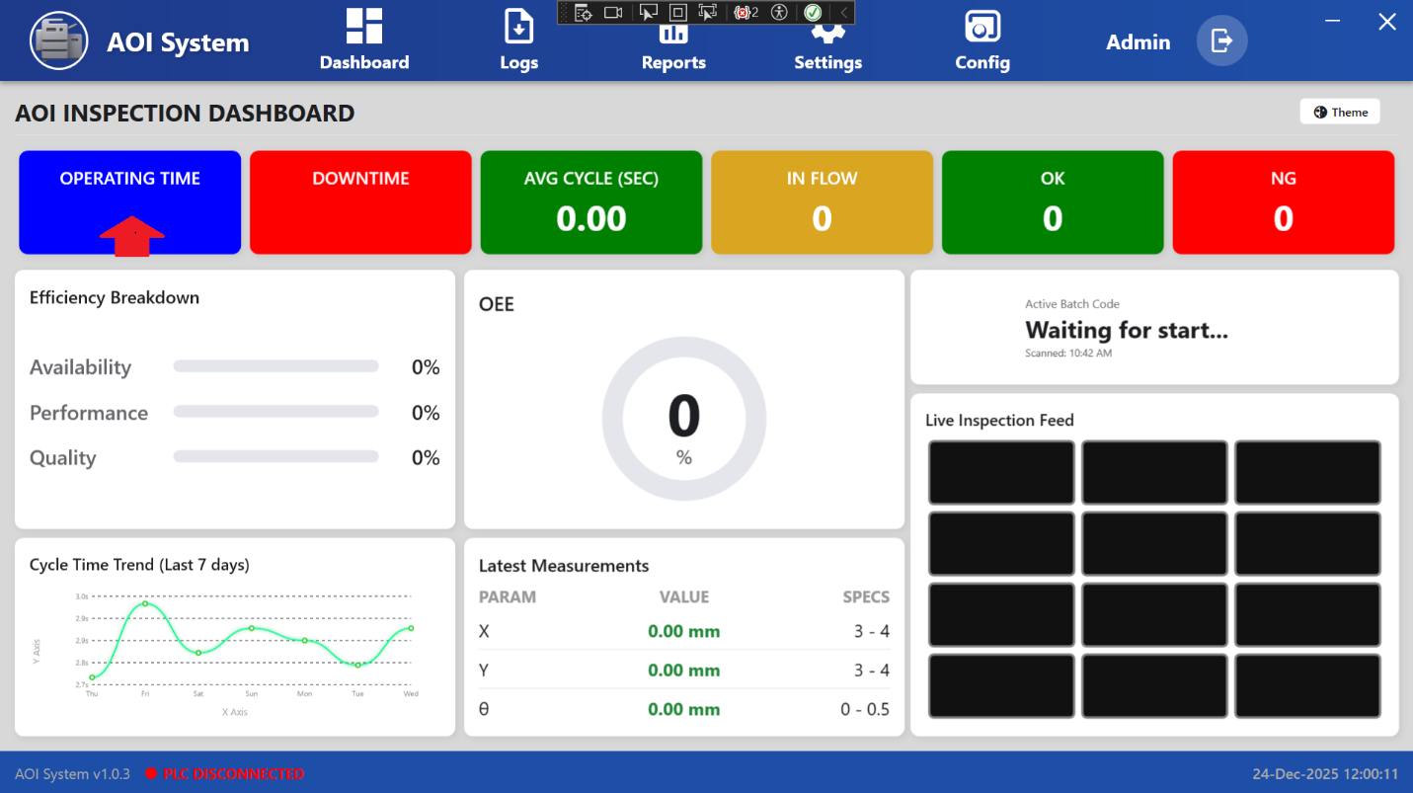

## 7.2 Purpose of the Screen

The Operating Time screen displays the **machine running time summary**.  
It helps the Operator understand how long the system has been operating over different time periods.

This screen is used only for monitoring and review.

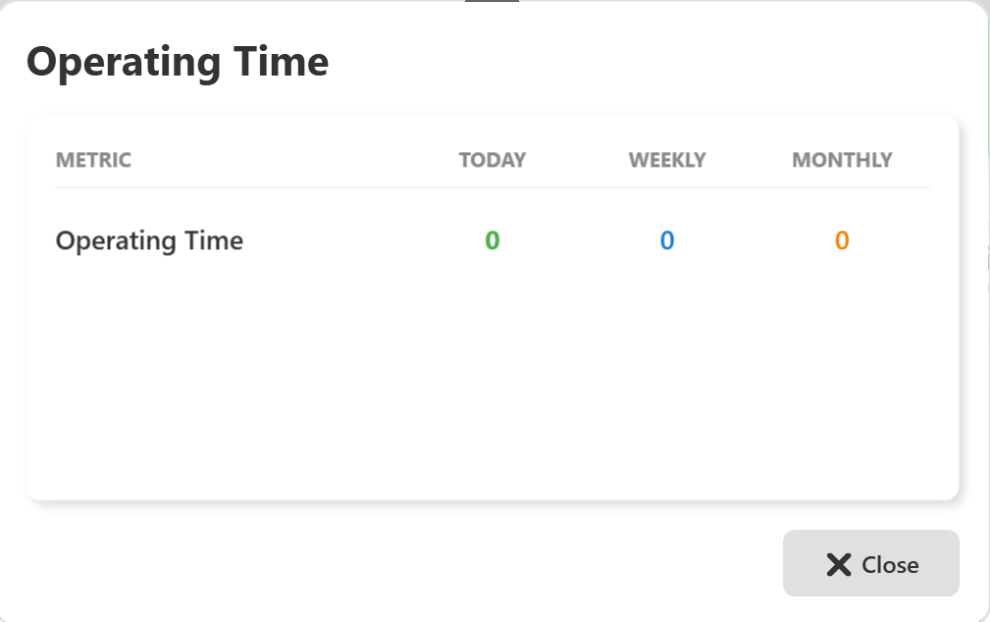

## 7.3 Screen Overview

The screen shows operating time data in a tabular format with the following columns:

* **Metric**
* **Today**
* **Weekly**
* **Monthly**

## 7.4 Displayed Information

### **7.5 Operating Time**

* **Today**  
  Shows the total operating time for the current day.
* **Weekly**  
  Shows the total operating time for the current week.
* **Monthly**  
  Shows the total operating time for the current month.

If the values are shown as **0**, it indicates:

* The machine has not started operation yet, or
* No operating data is available for the selected period.

## 7.6 Operator Actions

From this screen, the Operator can:

* View operating time statistics
* Compare daily, weekly, and monthly usage
* Close the screen after review

There are **no edit or control actions** available on this screen.

## 7.7 Close Action

* Click the **Close (X)** button to exit the Operating Time screen.
* The system will return to the previous dashboard view.

## 7.8 Important Notes for Operator

* Operating Time values update automatically based on machine activity.
* If values remain zero during production, check:
  + Machine running status
  + PLC connection status
* Report data issues to the system administrator.

**8 Downtime Statistics – Detail View**

## 8.1 Screen Name

**Downtime Statistics – Detail View**

## 8.2 Purpose of the Screen

The Downtime Statistics screen displays a **summary of machine stoppages**.  
It helps the Operator understand how often and for how long the machine was stopped.

This screen is used for **monitoring and review purposes only**.

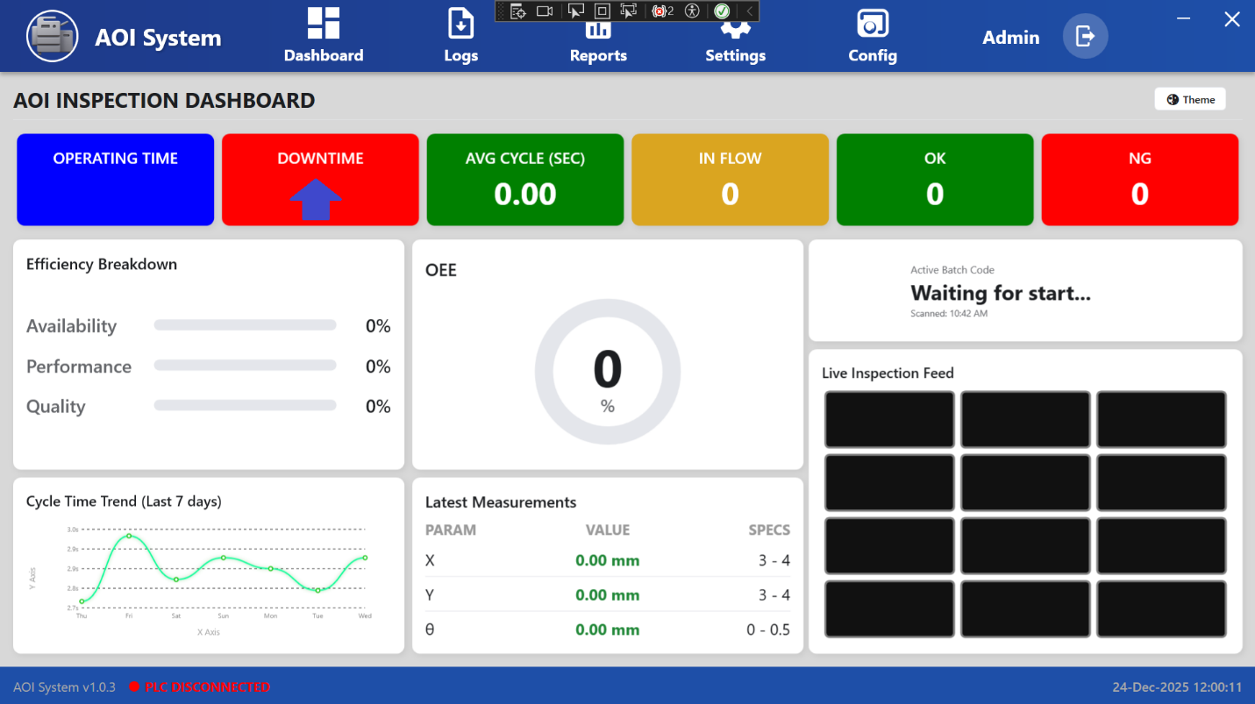

## 8.3 Screen Overview

The screen presents downtime data in a table with the following columns:

* **Metric**
* **Today**
* **Weekly**
* **Monthly**

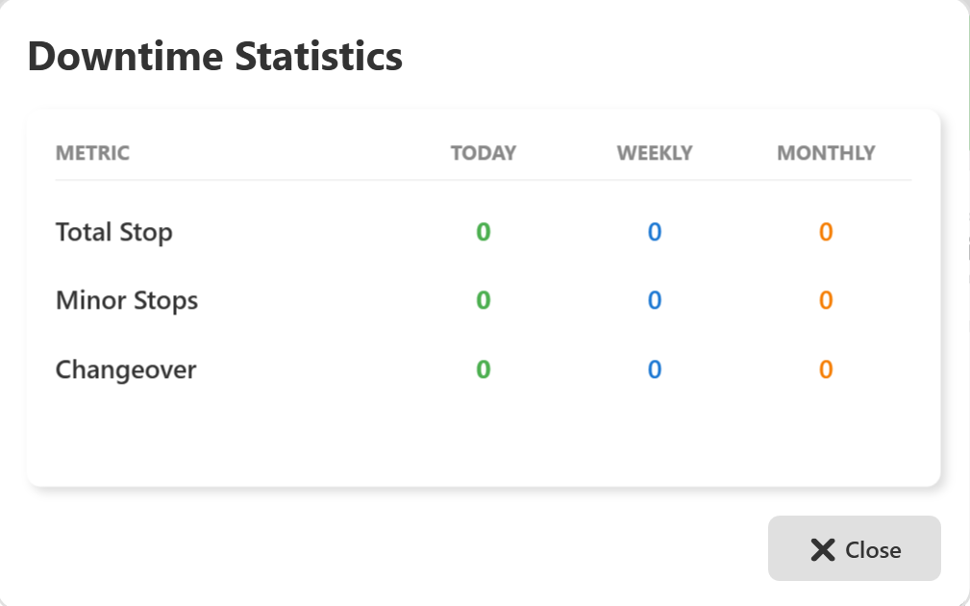

## 8.4 Displayed Metrics

### **1 Total Stop**

* Shows the total number of machine stops.
* Includes all stop events during the selected period.

### **2 Minor Stops**

* Shows the number of short-duration stops.
* Usually caused by small interruptions or brief pauses.

### **3 Changeover**

* Shows downtime caused by product or batch changeover.
* Includes setup and adjustment time.

If values are shown as **0**, it means:

* No downtime occurred, or
* No downtime data is available for the selected period.

## 8.5 Operator Actions

From this screen, the Operator can:

* Review downtime statistics
* Compare Today, Weekly, and Monthly values
* Close the screen after reviewing data

No changes or inputs are allowed on this screen.

## 8.6 Close Action

* Click the **Close (X)** button to exit the Downtime Statistics screen.
* The system returns to the previous dashboard view.

## 8.7 Important Notes for Operator

* Downtime data is automatically recorded by the system.
* Frequent minor stops should be reported to maintenance.
* Changeover downtime helps evaluate setup efficiency.

### **9 Avg Cycle (Sec) – Detail View**

## 9.1 Screen Name

**Avg Cycle (Sec)**

(Same as displayed in the application UI)

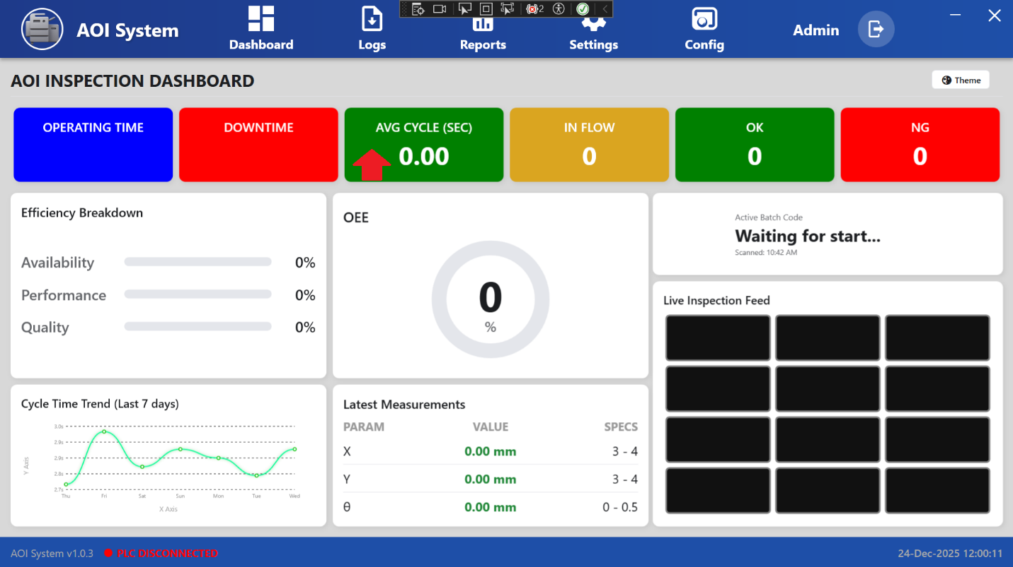

## 9.2 Purpose of the Screen

The **Avg Cycle (Sec)** screen shows the **average inspection cycle time** of the system.  
It helps the Operator understand how much time the machine takes to inspect one board or component.

This screen is used only for **monitoring and performance review**.

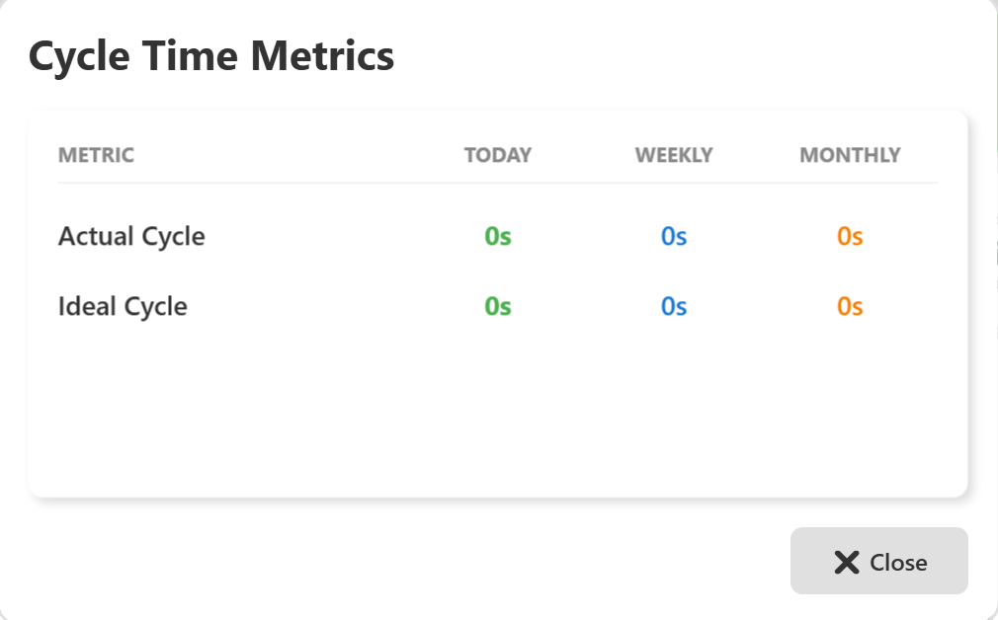

## 9.3 Screen Overview

The screen displays data in a table format with the following columns:

* **Metric**
* **Today**
* **Weekly**
* **Monthly**

All values are displayed in **seconds (s)**.

## 9.4 Displayed Metrics

### **1 Actual Cycle**

* Shows the actual average cycle time taken by the machine.
* Represents real inspection time.

### **2 Ideal Cycle**

* Shows the standard or expected cycle time.
* Used as a reference to compare machine performance.

If values are shown as **0s**, it means:

* Inspection has not started yet, or
* No cycle time data is available.

## 9.5 Operator Actions

From this screen, the Operator can:

* View actual cycle time
* Compare it with ideal cycle time
* Review Today, Weekly, and Monthly values
* Close the screen after checking data

No input or configuration is allowed on this screen.

## 9.6 Close Action

* Click the **Close (X)** button to exit the **Avg Cycle (Sec)** screen.
* The system returns to the OEE Dashboard.

## 9.7 Important Notes for Operator

* Actual cycle time should be close to the ideal cycle time.
* Higher cycle time may indicate performance issues.
* If values remain zero during production, check machine and PLC status.

**10 Input Statistics**

## 10.1 Screen Name

**Input Statistics**

(Opened when Operator clicks on ***In Flow***)

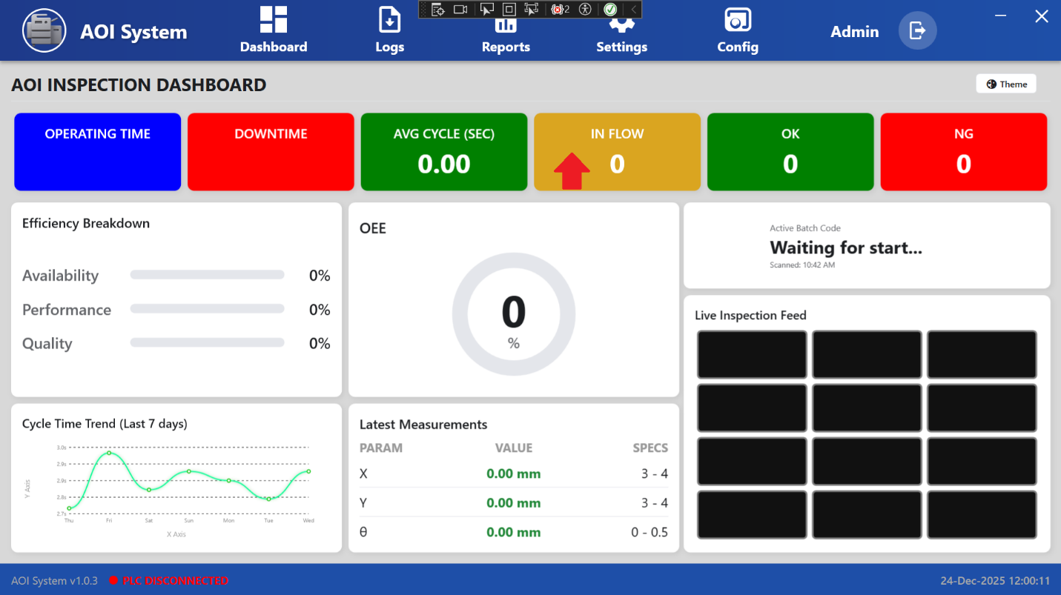

## 10.2 Purpose of the Screen

The **Input Statistics** screen shows the **total number of inputs received by the system**.  
It helps the Operator understand how many boards or components have entered the inspection process.

This screen is used for **monitoring production input only**.

## 10.3 Screen Overview

The screen displays input data in a table with the following columns:

* **Metric**
* **Today**
* **Weekly**
* **Monthly**

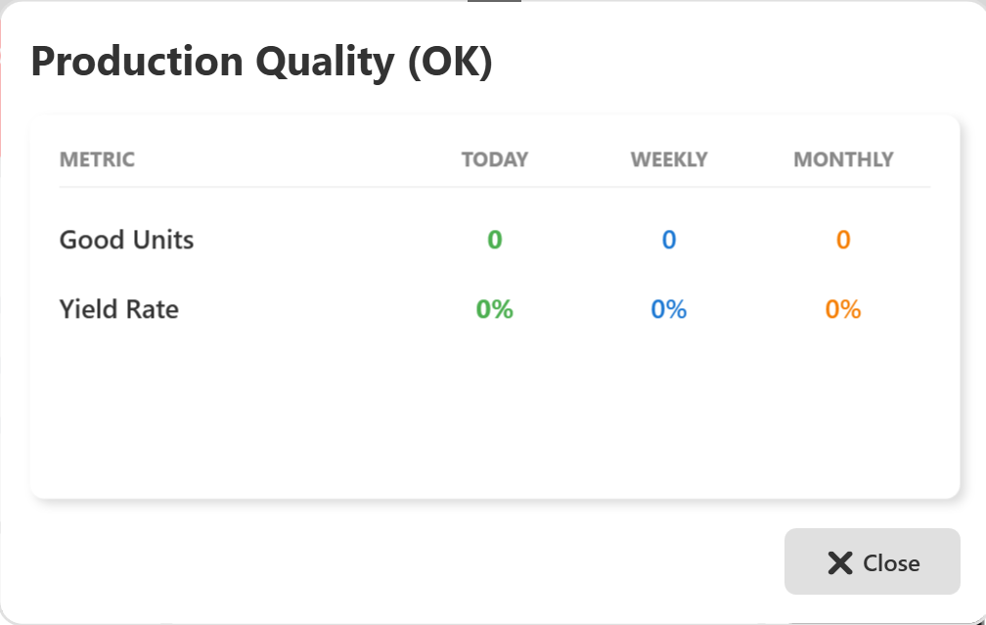

## 10.4 Displayed Metric

### **1 Total Input**

* Shows the total number of boards/components received by the system.
* Values are shown for:
  + Current day
  + Current week
  + Current month

If the value is **0**, it means:

* No input has been received yet, or
* Inspection has not started, or
* No data is available for the selected period.

## 10.5 Operator Actions

From this screen, the Operator can:

* View total input count
* Compare Today, Weekly, and Monthly input values
* Close the screen after reviewing information

No editing or control actions are available on this screen.

## 10.6 Close Action

* Click the **Close (X)** button to exit the **Input Statistics** screen.
* The system returns to the OEE Dashboard.

## 10.7 Important Notes for Operator

* Input count updates automatically when boards enter the system.
* If input remains zero during production:
  + Check machine status
  + Verify PLC connection
* Report any data mismatch to the supervisor or administrator.

**11 Production Quality (OK)**

## 11.1 Screen Name

**Production Quality (OK)**

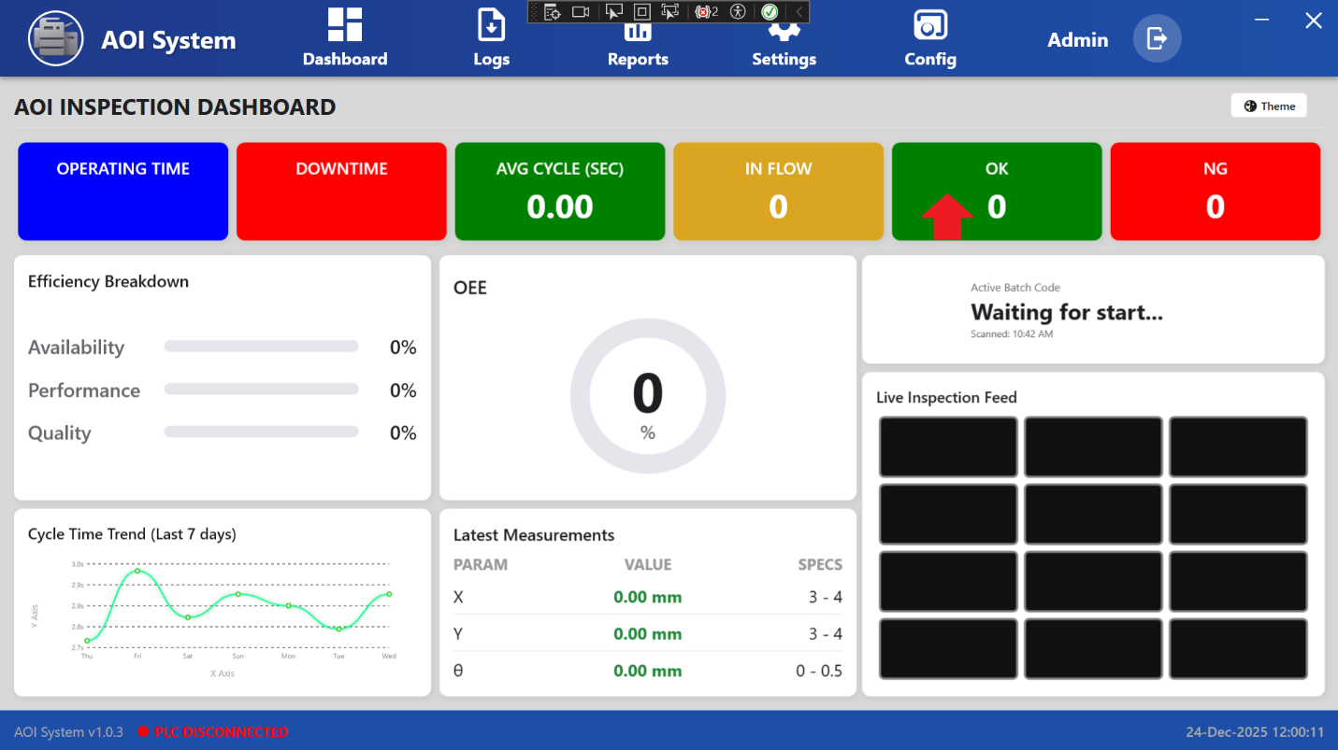

## 11.2 Purpose of the Screen

The **Production Quality (OK)** screen shows information about **good units that have passed inspection**.  
It helps the Operator monitor production quality and yield performance.

This screen is used for **quality monitoring only**.

## 11.3 Screen Overview

The screen displays quality data in a table format with the following columns:

* **Metric**
* **Today**
* **Weekly**
* **Monthly**



## 11.4 Displayed Metrics

### **1 Good Units**

* Shows the total number of units that passed inspection (OK).
* Values are shown for today, this week, and this month.

### **2 Yield Rate**

* Shows the percentage of good units compared to total input.
* Helps measure production quality efficiency.

If values are **0 or 0%**, it means:

* Inspection has not started, or
* No data is available for the selected period.

## 11.5 Operator Actions

From this screen, the Operator can:

* Review good unit count
* Check yield rate
* Compare Today, Weekly, and Monthly values
* Close the screen after review

No editing or control actions are available.

## 11.6 Close Action

* Click the **Close (X)** button to exit the **Production Quality (OK)** screen.
* The system returns to the OEE Dashboard.

## 11.7 Important Notes for Operator

* Yield rate improves when more units pass inspection.
* A sudden drop in yield rate should be reported immediately.
* Verify NG data if OK count remains unexpectedly low.

**12 Rejection Statistics (NG)**

## 12.1 Screen Name

**Rejection Statistics (NG)**

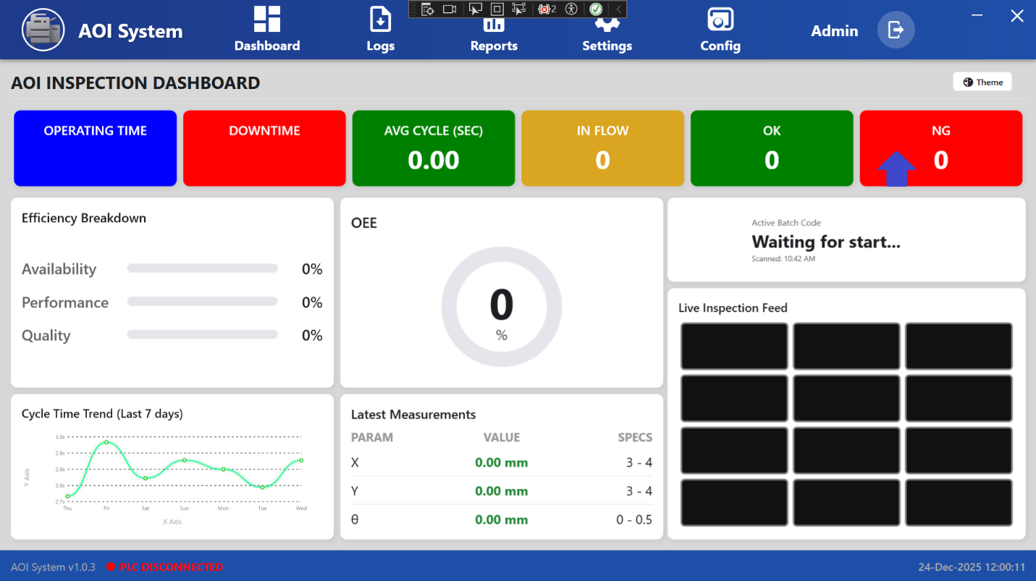

## 12.2 Purpose of the Screen

The **Rejection Statistics (NG)** screen shows information about **units that failed inspection**.  
It helps the Operator monitor rejection count and identify quality issues.

This screen is used for **quality monitoring and analysis only**.

## 12.3 Screen Overview

The screen displays rejection data in a table format with the following columns:

* **Metric**
* **Today**
* **Weekly**
* **Monthly**

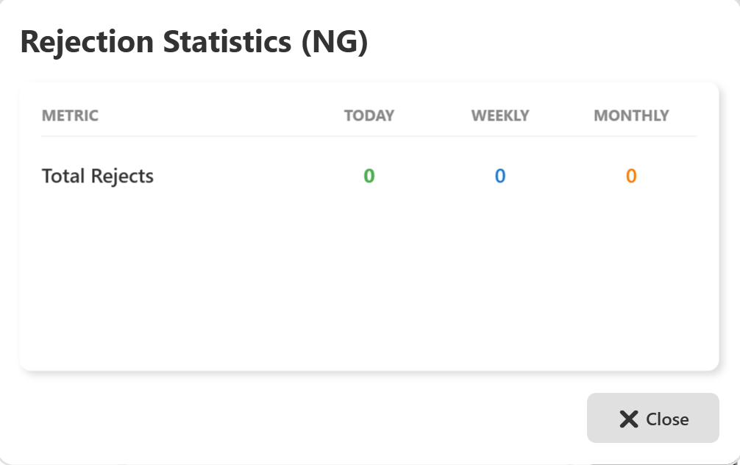

## 12.4 Displayed Metric

### **1 Total Rejects**

* Shows the total number of rejected units (NG).
* Values are shown for:
  + Today
  + This week
  + This month

If the values are **0**, it means:

* No units have been rejected, or
* Inspection has not started, or
* No data is available for the selected period.

## 12.5 Operator Actions

From this screen, the Operator can:

* Review total reject count
* Compare Today, Weekly, and Monthly values
* Close the screen after reviewing data

No editing or configuration actions are available.

## 12.6 Close Action

* Click the **Close (X)** button to exit the **Rejection Statistics (NG)** screen.
* The system returns to the OEE Dashboard.

## 12.7 Important Notes for Operator

* High NG values indicate quality problems.
* Repeated rejections should be reported immediately.
* Compare NG values with OK and Input data for analysis.

**13 Efficiency Breakdown Details**

## 13.1 Screen Name

**Efficiency Breakdown Details**

(Opened when Operator clicks on ***Efficiency Breakdown***)

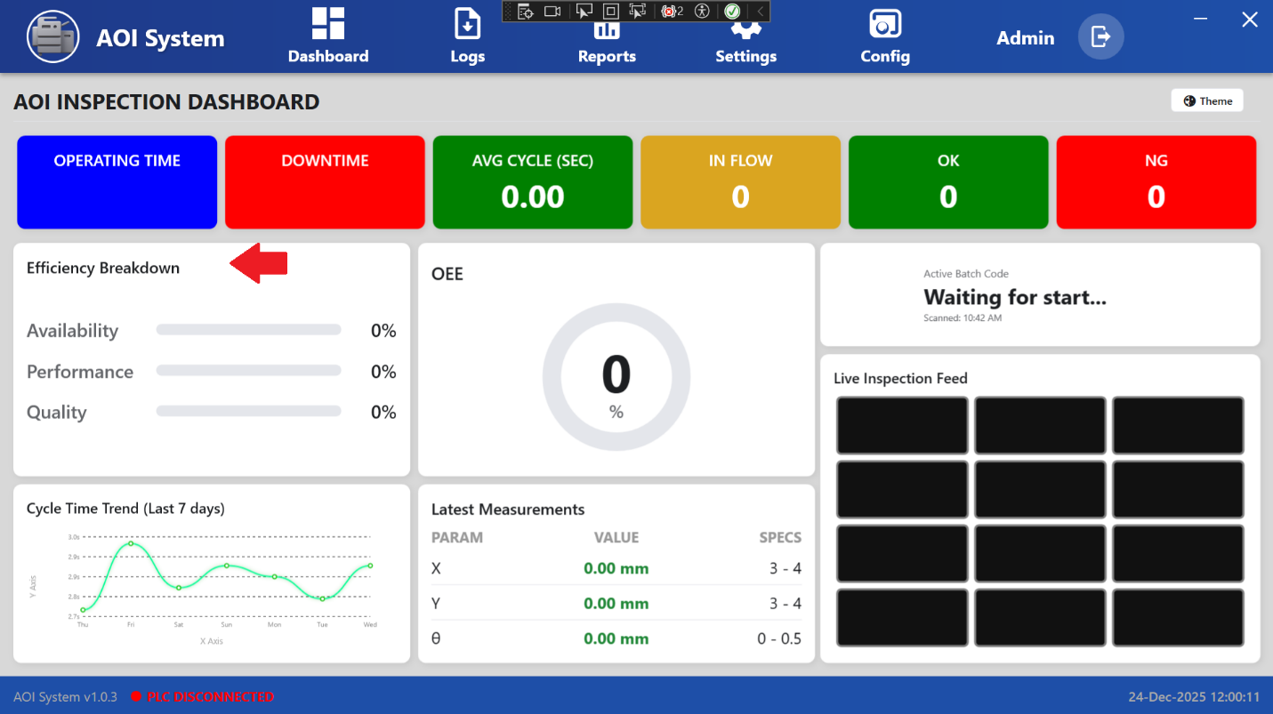

## 13.2 Purpose of the Screen

The **Efficiency Breakdown Details** screen shows the detailed efficiency values used to calculate **OEE**.  
It helps the Operator understand **why efficiency is high or low**.

This screen is **view-only** and used for monitoring.

## 13.3 Screen Overview

The screen displays efficiency data in a table with the following columns:

* **Metric**
* **Today**
* **Weekly**
* **Monthly**

All values are displayed in **percentage (%)**.

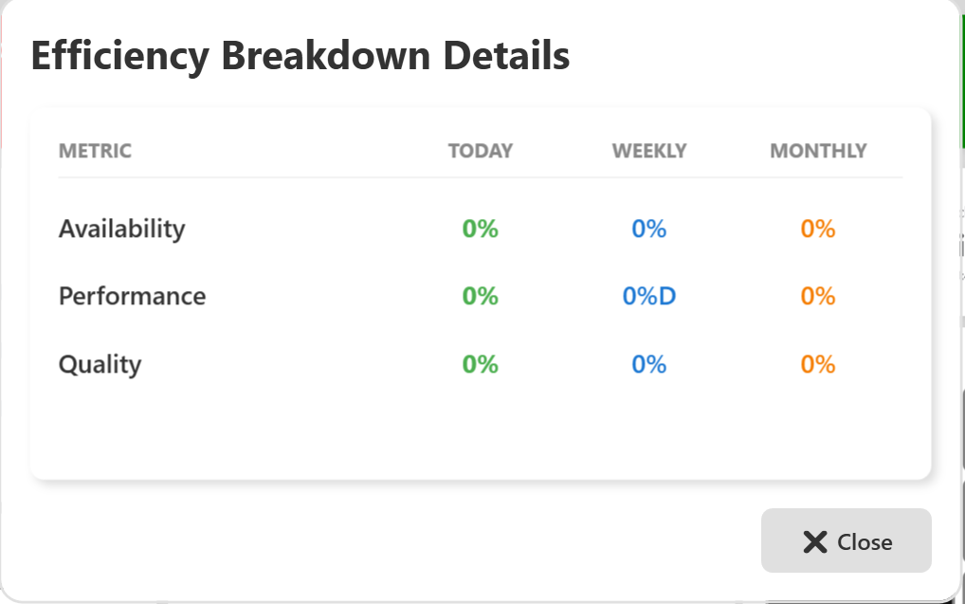

## 13.4 Displayed Metrics

### **1 Availability**

* Shows how much time the machine was **available for operation**.
* Affected by machine stops and downtime.

### **2 Performance**

* Shows how efficiently the machine is running compared to the **ideal cycle time**.
* Lower value indicates slower operation.

### **3 Quality**

* Shows the percentage of **good units (OK)** compared to total input.
* Lower value indicates higher rejections (NG).

If values are **0%**, it means:

* Production has not started, or
* No valid data is available, or
* PLC is not connected.

## 13.5 Operator Actions

From this screen, the Operator can:

* View Availability, Performance, and Quality values
* Compare Today, Weekly, and Monthly efficiency
* Identify which area is affecting efficiency
* Close the screen after review

No changes or inputs are allowed.

**13.6 Close Action**

* Click the **Close (X)** button to exit the **Efficiency Breakdown Details** screen.
* The system returns to the **OEE Inspection Dashboard**.

**13.7 Important Notes for Operator**

* All three values affect overall OEE.
* Low **Availability** → check Downtime
* Low **Performance** → check Avg Cycle (Sec)
* Low **Quality** → check OK / NG data
* If values remain 0%, check PLC connection and system status.

**14** **OEE Score Statistics**

## 14.1 Screen Name

**OEE Score Statistics**

(Opened when Operator clicks on ***OEE*** score)

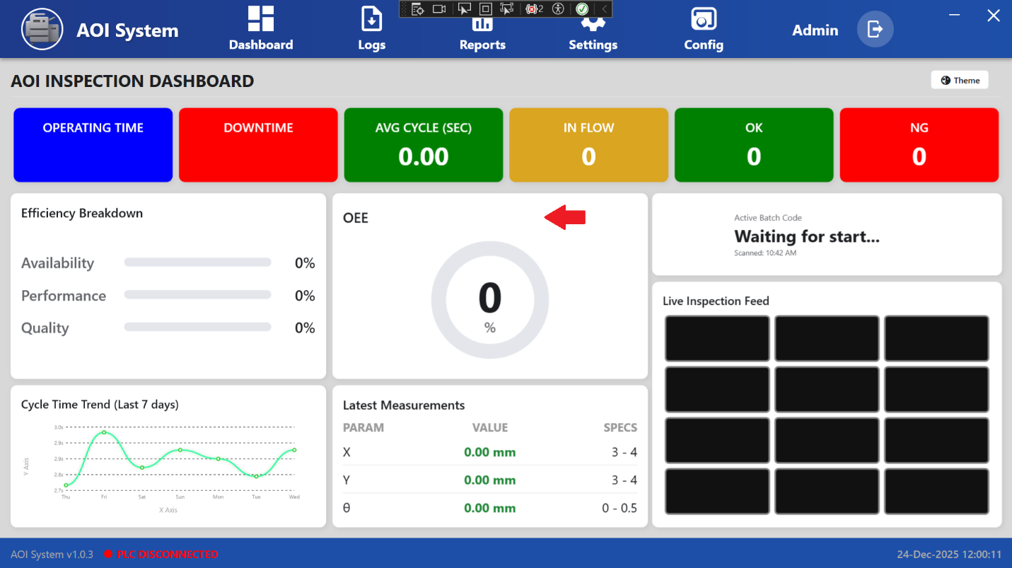

## 14.2 Purpose of the Screen

The **OEE Score Statistics** screen shows the **Overall Equipment Effectiveness (OEE) score**.  
It gives the Operator a **single percentage value** that represents the overall system efficiency.

This screen is **view-only** and used for monitoring performance.

## 14.3 Screen Overview

The screen displays OEE data in a table format with the following columns:

* **Metric**
* **Today**
* **Weekly**
* **Monthly**

All values are shown in **percentage (%)**.

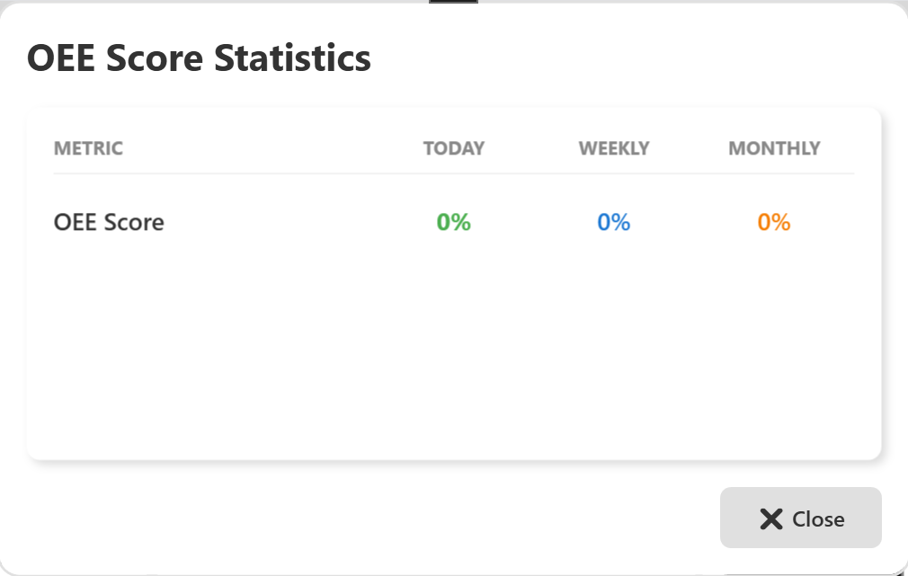

## 14.4 Displayed Metric

### **1 OEE Score**

* Shows the overall efficiency of the system.
* OEE score is calculated based on:
  + Availability
  + Performance
  + Quality

A higher OEE score indicates better system performance.

If the value is **0%**, it means:

* Production has not started, or
* Required data is not available, or
* PLC is not connected.

## 14.5 Operator Actions

From this screen, the Operator can:

* View the OEE score
* Compare Today, Weekly, and Monthly OEE values
* Monitor overall production efficiency
* Close the screen after review

No editing or control actions are allowed.

## 14.6 Close Action

* Click the **Close (X)** button to exit the **OEE Score Statistics** screen.
* The system returns to the **OEE Inspection Dashboard**.

## 14.7 Important Notes for Operator

* OEE score depends on Availability, Performance, and Quality.
* Low OEE score means one or more efficiency areas need attention.
* Check **Efficiency Breakdown Details** to understand the reason for low OEE.
* If OEE remains 0% during production, check PLC connection and system status.

**15 Time Sync (System Synchronization)**

## 15.1 Navigation Path

**Dashboard → Time Sync**

The **Time Sync** option is available inside the **Dashboard menu**.  
The Operator can access it using the left-side menu.

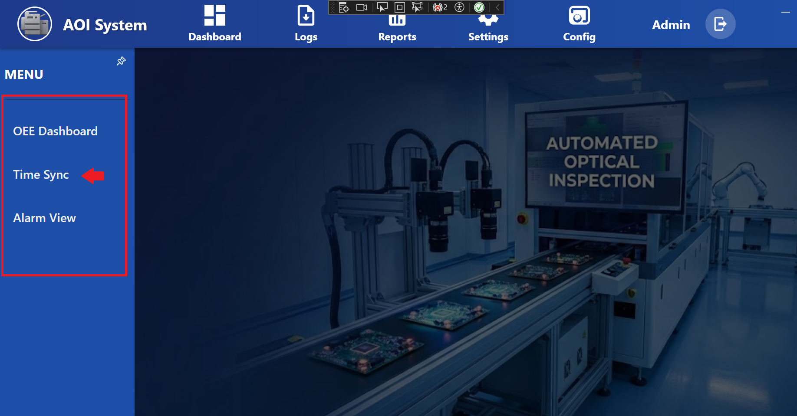

## 15.2 Purpose of Time Sync

The **Time Sync** function is used to **synchronize date and time between IPC and PLC**.  
Correct time synchronization is important for:

* Accurate logs
* Correct reports
* Alarm timestamps
* Audit trail records

## 15.3 Screen Name

**System Synchronization**

(This screen opens when Operator clicks on ***Time Sync***)

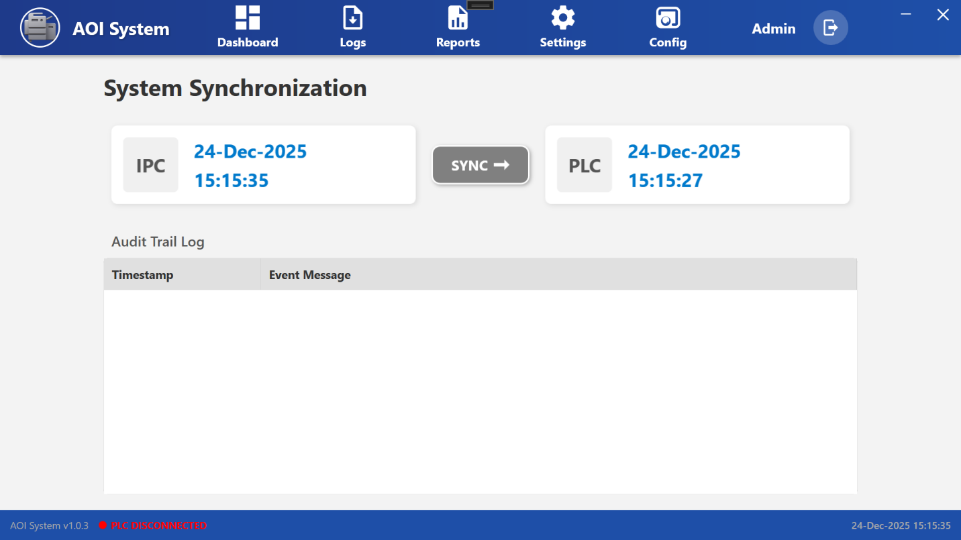

## 15.4 Screen Overview

The **System Synchronization** screen contains three main sections:

1. **IPC Time Panel**
2. **PLC Time Panel**
3. **Audit Trail Log**

## 15.5 IPC Time Panel

* Displays the **current date and time of the IPC**.
* This time is used as the **reference time**.

Example:

* Date: 24-Dec-2025
* Time: 15:15:35

## 15.6 PLC Time Panel

* Displays the **current date and time of the PLC**.
* Used to compare PLC time with IPC time.

Example:

* Date: 24-Dec-2025
* Time: 15:15:27

## 15.7 Sync Button (SYNC →)

* Clicking **SYNC →** updates the **PLC time to match the IPC time**.
* After successful synchronization:
  + PLC time is updated
  + An entry is added to the **Audit Trail Log**
* **Important:**
* Time synchronization should be performed only when the PLC is connected.
* Do not perform sync during active inspection.

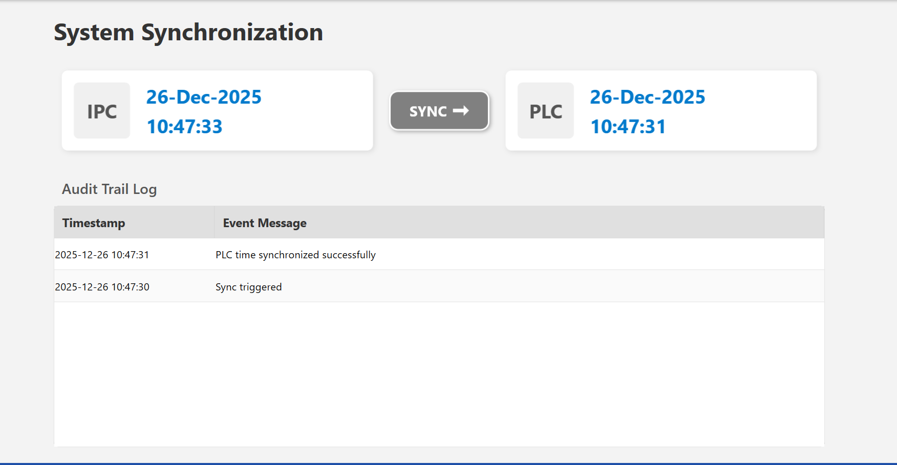

## 15.8 Audit Trail Log

The **Audit Trail Log** records all time synchronization events.

### Columns:

* **Timestamp** – Date and time of the sync action
* **Event Message** – Description of the synchronization activity

This log is used for **traceability and audits**.

## 15.9 Operator Actions

From the **Time Sync** screen, the Operator can:

* View IPC time
* View PLC time
* Synchronize PLC time with IPC
* Review synchronization history

## 15.10 Operator Limitations

* Operator cannot manually edit time values.
* Operator can only sync PLC time with IPC time.
* Advanced time settings are restricted to Admin users.

## 15.11 Important Notes for Operator

* Always check **PLC connection status** before clicking Sync.
* If **PLC DISCONNECTED** is shown at the bottom:
  + Do not perform sync
  + Inform supervisor or administrator
* Perform time sync before starting production for accurate data.

**16 Alarm View**

## 16.1 Screen Name

**Alarm View**

(Opened when Operator clicks on ***Alarm View*** from Dashboard menu)

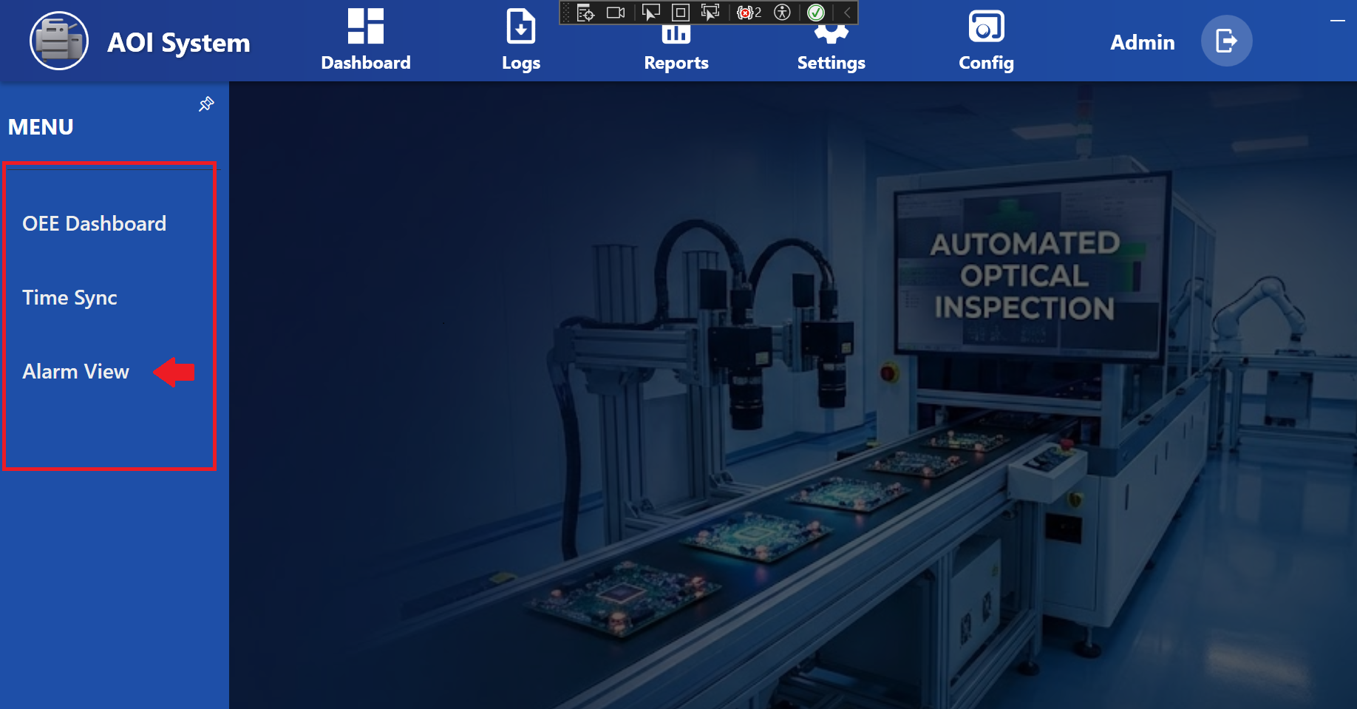

## 16.2 Purpose of the Screen

The **Alarm View** screen displays all **active system alarms**.  
It helps the Operator quickly identify problems in the system and take immediate action.

This screen is mainly used for monitoring and immediate response*.*

## 16.3 Screen Overview

The Alarm View screen contains:

* **Active Alarms Table**
* **Reset System** button

## 

## 16.4 Active Alarms Table

The table displays the list of currently active alarms with the following columns:

* **Alarm No**  
  Unique identification number of the alarm.
* **Severity**  
  Indicates the seriousness of the alarm  
  (for example: High, Medium, Low).
* **Message**  
  Describes the alarm reason or issue.
* **Raised At**  
  Shows the date and time when the alarm occurred.
* **Reset At**  
  Shows the date and time when the alarm was cleared.

If the table is empty, it means:

* No active alarms are present, or
* The system is currently running normally.

## 16.5 Reset System Button

### **Reset System**

* The **Reset System** button is used to clear alarms after the issue is resolved.
* This action may require proper authorization depending on system configuration.

**Important for Operator**:

* Do not reset alarms without understanding the issue.
* Always inform the supervisor before resetting critical alarms.

## 16.6 Operator Actions

From the Alarm View screen, the Operator can:

* View active alarms
* Check alarm severity and message
* Note the time when alarms occurred
* Reset the system (if permitted)

## 16.7 Operator Limitations

* Operator cannot edit alarm definitions.
* Alarm configuration is restricted to Admin users.
* Some alarms may not allow reset until the issue is fixed.

## 16.8 Important Notes for Operator

* Always check **PLC connection status** at the bottom of the screen.
* If **PLC DISCONNECTED** is shown:
  + Expect communication-related alarms
  + Inform maintenance or administrator
* Repeated alarms should be escalated immediately.

**17 Logs**

## 17.1 Navigation Path

**Top Menu → Logs**

When the Operator clicks on **Logs**, a left-side menu opens with different log categories.

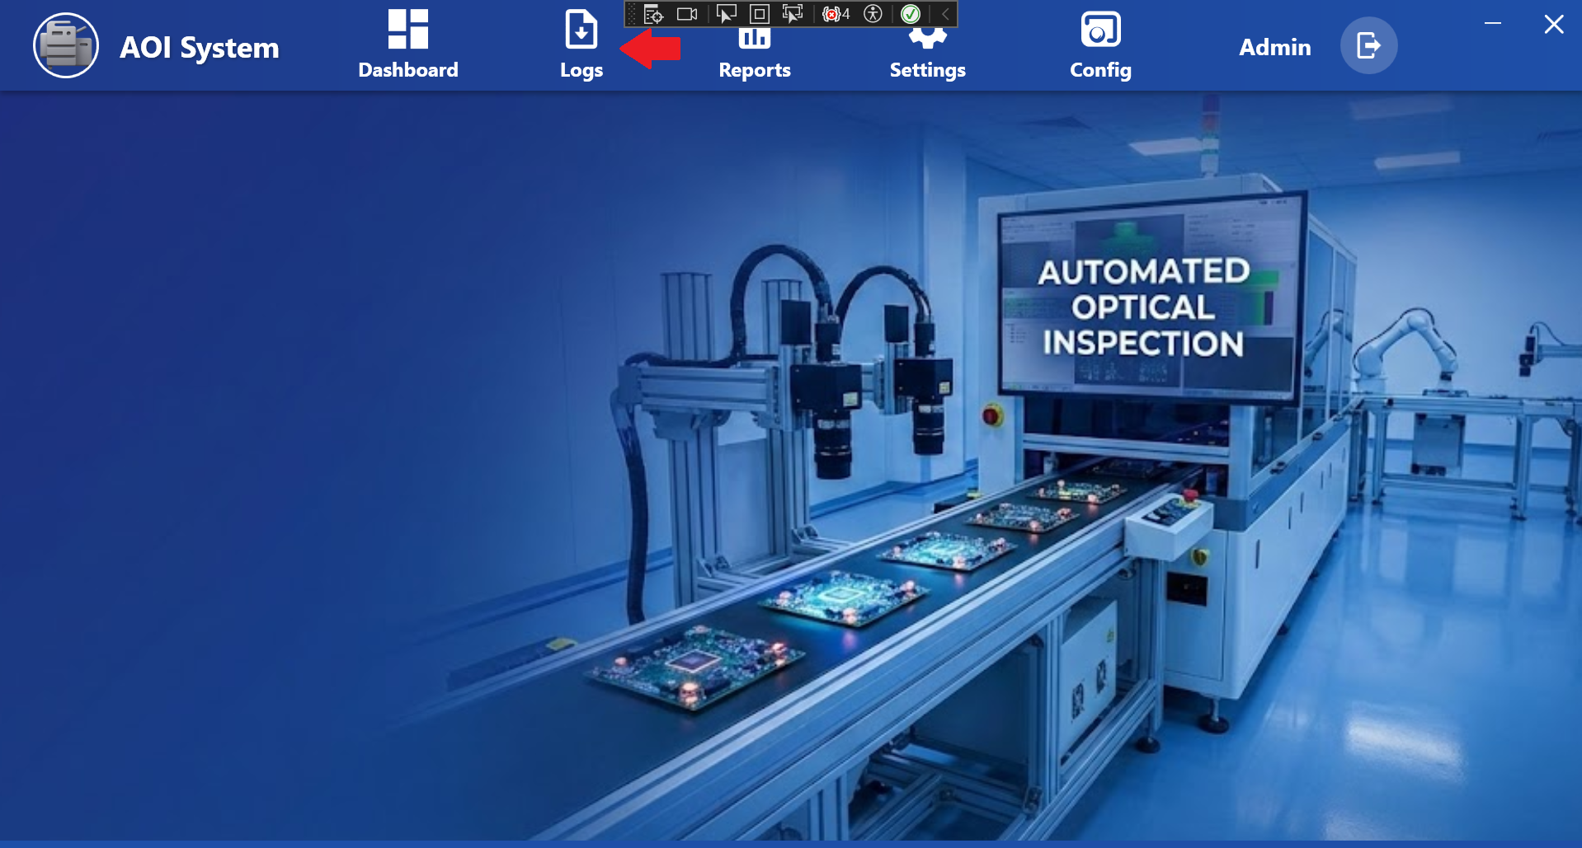

## 17.2 Purpose of Logs

The **Logs** section is used to **view system history and events**.  
It helps the Operator understand:

* What actions happened
* When issues occurred
* How the system behaved during production

All logs are **view-only** for Operator.

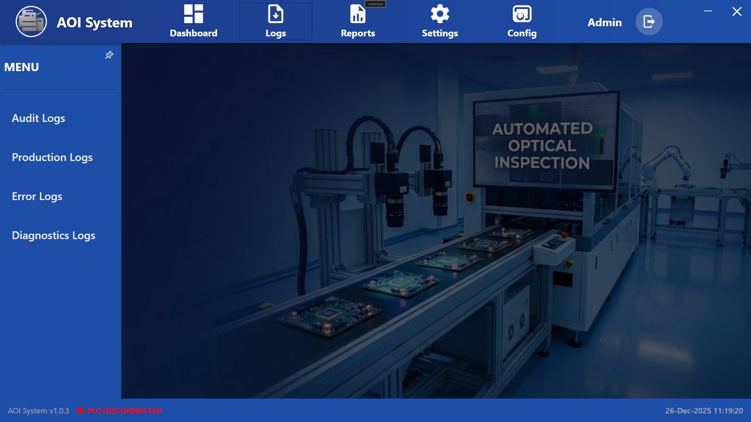

## 17.3 Available Log Options

The following log options are available under **Logs**:

* **Audit Logs**
* **Production Logs**
* **Error Logs**
* **Diagnostics Logs**

## 17.4 Audit Logs

### **Screen Name**

**Audit Logs**

### **Purpose**

Audit Logs record **user actions and system events** for traceability.

### **Typical Information**

* Login / Logout events
* Time synchronization actions
* Configuration-related activities

### **Operator Action**

* View audit records
* No editing or deletion allowed

## 17.5 Production Logs

### **Screen Name**

**Production Logs**

### **Purpose**

Production Logs record **inspection and production-related activities**.

### **Typical Information**

* Start and stop of inspection
* Batch or job-related events
* Production flow information

### **Operator Action**

* Review production history
* Use logs for production verification

## 17.6 Error Logs

### **Screen Name**

**Error Logs**

### **Purpose**

Error Logs record **system errors and failures**.

### **Typical Information**

* PLC communication errors
* System faults
* Runtime errors

### **Operator Action**

* Identify error messages
* Inform maintenance or administrator

## 17.7 Diagnostics Logs

### **Screen Name**

**Diagnostics Logs**

### **Purpose**

Diagnostics Logs provide **technical diagnostic information**.

### **Typical Information**

* Hardware status
* Communication diagnostics
* System health details

### **Operator Action**

* View diagnostics data
* Share details with technical support if required

## 17.8 Operator Limitations

* Operator cannot delete or modify logs.
* Logs are automatically generated by the system.
* Log configuration is restricted to Admin users.

## 17.9 Important Notes for Operator

* Always check **Error Logs** if the system behaves abnormally.
* Use **Audit Logs** for tracking important actions.
* Diagnostics Logs should be shared with support during troubleshooting.
* Logs help in audits and issue investigation.

**18 Audit log**

## 18.1 Screen Name

**Audit Logs**

(Opened when Operator clicks on ***Logs → Audit Logs***)

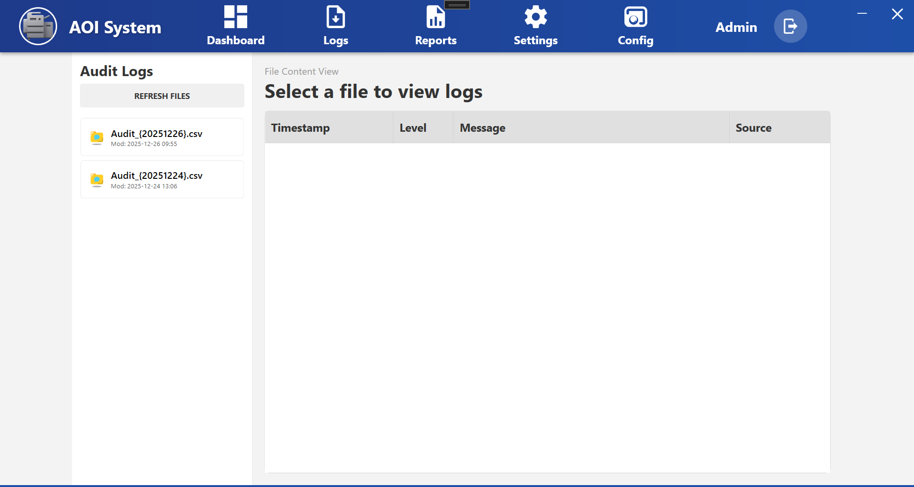

## 18.2 Purpose of the Screen

The **Audit Logs** screen is used to **view audit trail records** generated by the system.  
These logs help track **important user actions and system events** for traceability and audits.

This screen is **view-only** for the Operator.

## 18.3 Screen Layout Overview

The Audit Logs screen is divided into two main sections:

1. **File List Panel (Left Side)**
2. **Log Content View (Right Side)**

## 18.4 File List Panel

### **Available Options**

* **Refresh Files**  
  Reloads the list of available audit log files.
* **Audit Log Files (.csv)**  
  Displays audit log files with date-based names  
  (for example: Audit_{20251226}.csv).

Each file also shows:

* **Last Modified Date and Time**

## 18.5 Selecting an Audit Log File

To view audit logs:

1. Click on any **Audit_YYYYMMDD.csv** file from the left panel
2. The selected file content is displayed on the right side

## 18.6 Log Content View

The log data is displayed in a table with the following columns:

* **Timestamp**  
  Date and time when the event occurred.
* **Level**  
  Type or severity of the log entry  
  (for example: Info, Warning, Error).
* **Message**  
  Description of the action or event.
* **Source**  
  Indicates the system component that generated the log.

If no file is selected, the message  
**“Select a file to view logs”** is displayed.

## 18.7 Operator Actions

From the Audit Logs screen, the Operator can:

* Refresh the list of audit log files
* Select and view audit log files
* Review log entries for:
  + Login / logout events
  + Time synchronization actions
  + System-related activities

## 18.8 Operator Limitations

* Operator cannot edit or delete audit logs.
* Log file generation is automatic.
* Audit log configuration is restricted to Admin users.

## 18.9 Important Notes for Operator

* Audit logs are important for **compliance and traceability**.
* Always review audit logs if:
  + Unexpected system behavior occurs
  + Time sync or critical actions are questioned
* Share relevant log details with the administrator when required.

**19 Production Logs**

## 19.1 Screen Name

**Production Logs**

(Opened when Operator clicks on ***Logs → Production Logs***)

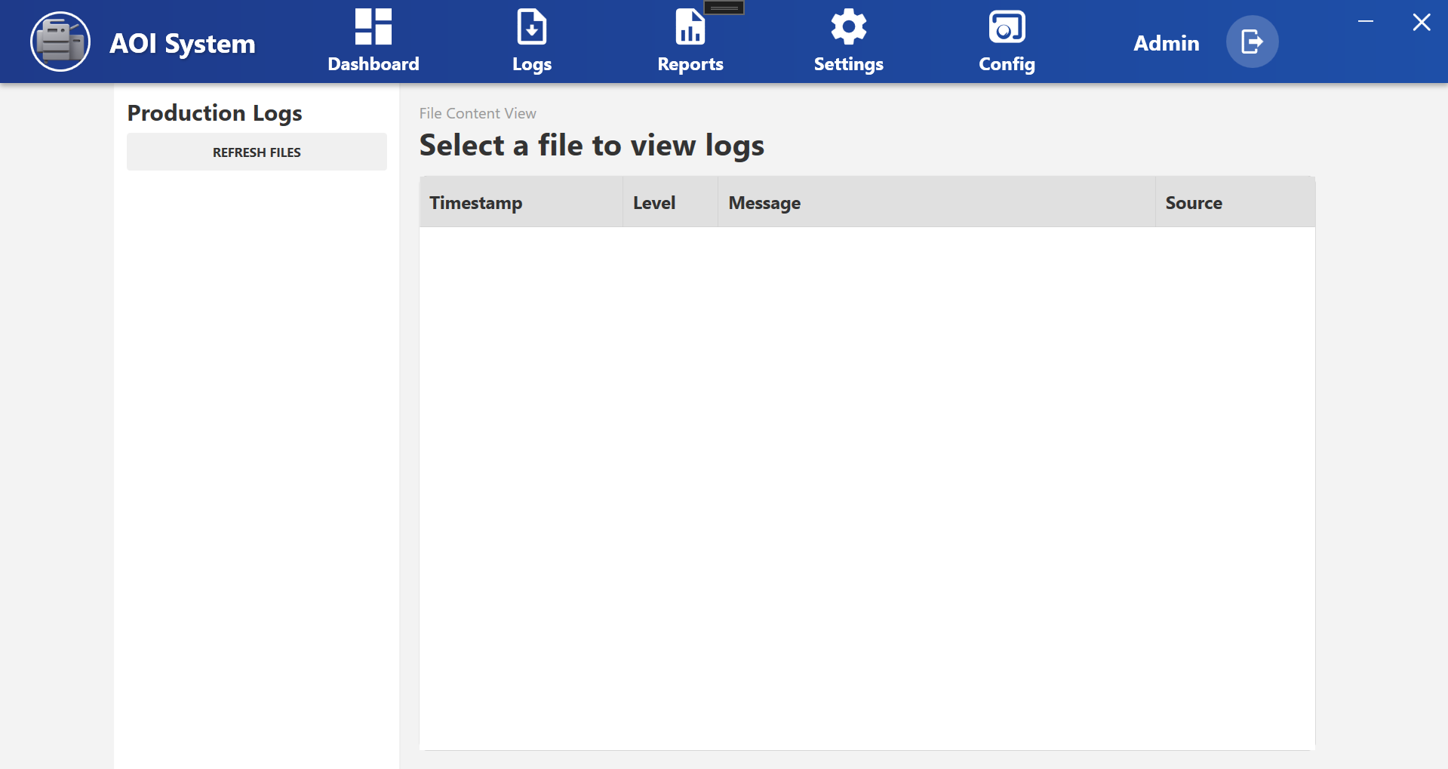

## 19.2 Purpose of the Screen

The **Production Logs** screen is used to **view production and inspection-related events** generated by the AOI System.  
It helps the Operator track **what happened during production** and **when it happened**.

This screen is **view-only** for the Operator.

## 19.3 Screen Layout Overview

The Production Logs screen is divided into two main sections:

1. **File List Panel (Left Side)**
2. **Log Content View (Right Side)**

## 19.4 File List Panel

### **Available Options**

* **Refresh Files**  
  Reloads the list of available production log files.
* **Production Log Files**  
  Displays production log files saved by date  
  (for example: Production_YYYYMMDD.csv).

Each file shows:

* Last modified date and time

## 19.5 Selecting a Production Log File

To view production logs:

1. Click on any production log file from the left panel
2. The selected file content is displayed on the right side

If no file is selected, the message  
**“Select a file to view logs”** is displayed.

## 19.6 Log Content View

The log data is shown in a table with the following columns:

* **Timestamp**  
  Date and time when the production event occurred.
* **Level**  
  Type of log entry (Info, Warning, etc.).
* **Message**  
  Description of the production or inspection event  
  (for example: inspection start, inspection stop, batch change).
* **Source**  
  Indicates which system component generated the log.

## 19.7 Operator Actions

From the Production Logs screen, the Operator can:

* Refresh the production log file list
* Select and view production log files
* Review production history for:
  + Inspection start/stop
  + Batch or job events
  + Production flow issues

## 19.8 Operator Limitations

* Operator cannot edit or delete production logs.
* Logs are automatically generated by the system.
* Production log settings are restricted to Admin users.

## 19.9 Important Notes for Operator

* Use Production Logs to verify production activities.
* If inspection stops unexpectedly, check Production Logs first.
* Share log details with the supervisor or support team if required.
* Logs are useful for audits and issue investigation.

**20** **Error Logs**

## 20.1 Screen Name

**Error Logs**

*(Opened when Operator clicks on* ***Logs → Error Logs****)*

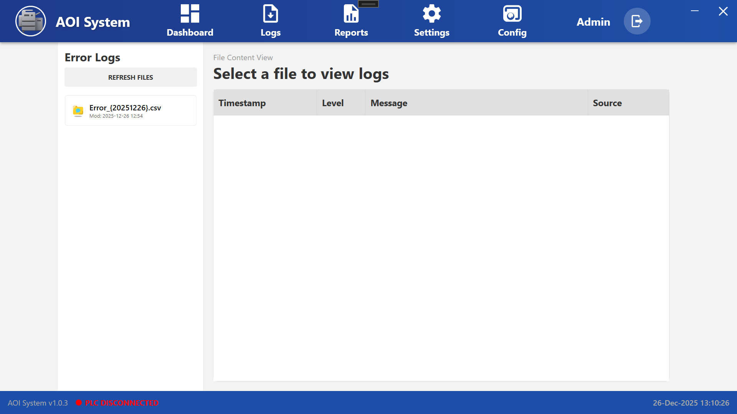

**20.2 Purpose of the Screen**

The **Error Logs** screen is used to **view system error records**.  
It helps the Operator identify **system-level problems** that may affect inspection or operation.

This screen is **view-only** for the Operator.

## 20.3 Navigation Flow

**Logs → Error Logs → Select Error File (.csv)**

After selecting an error log file, the system displays the list of recorded errors.

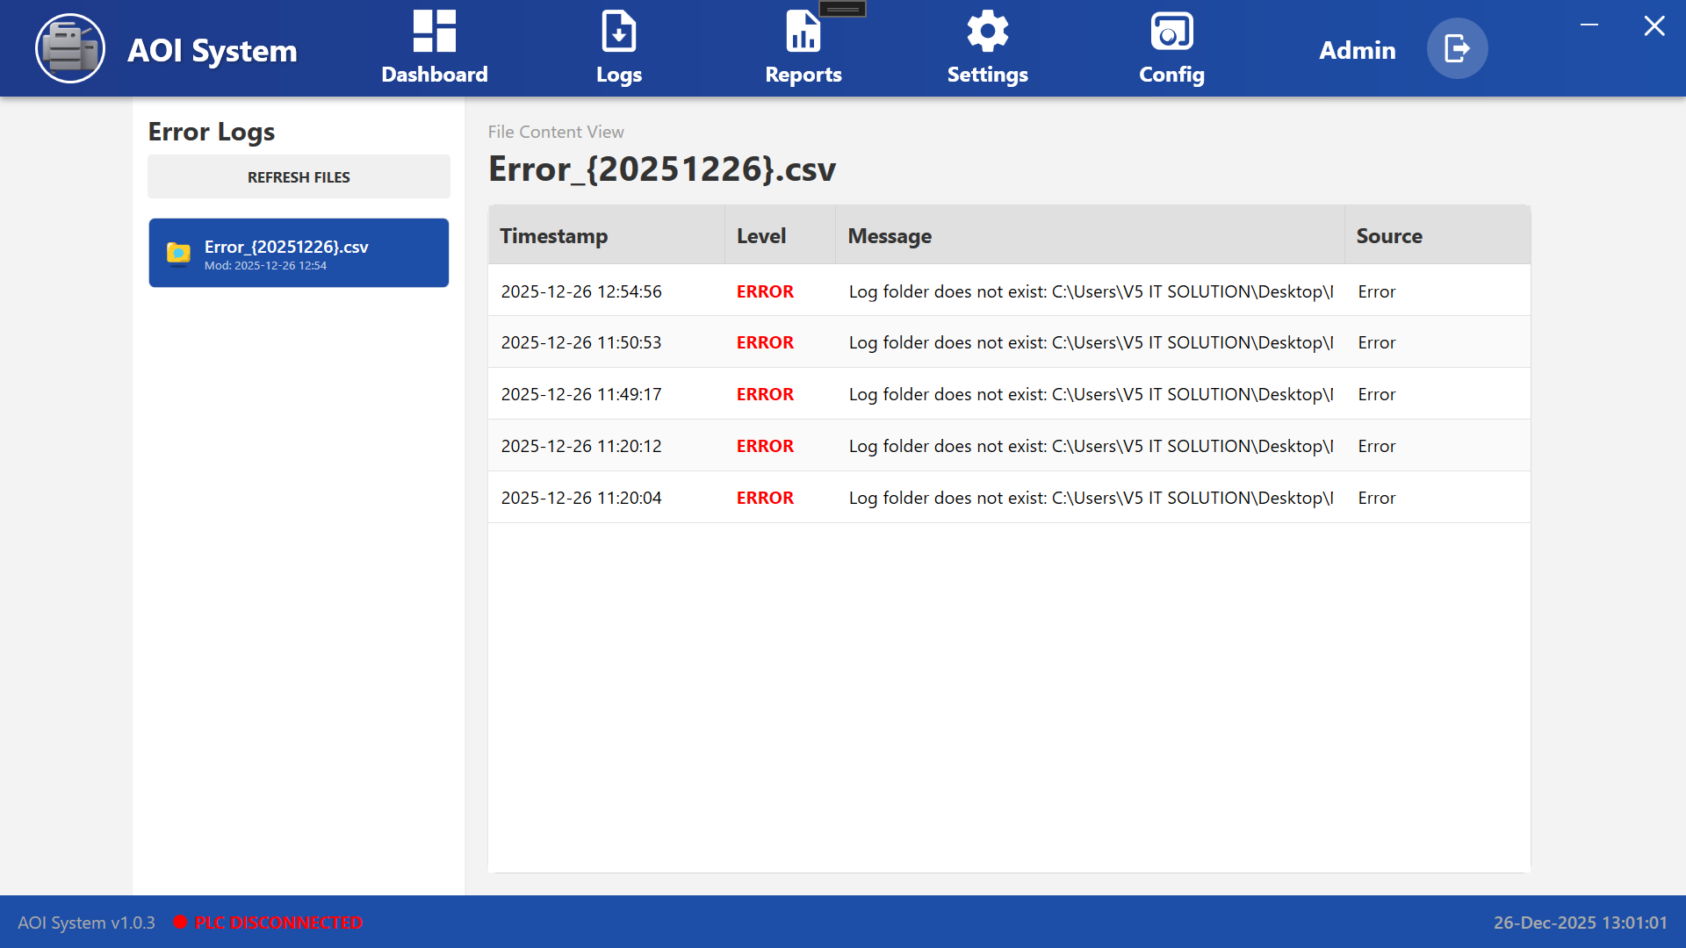

## 20.4 Screen Layout Overview

The Error Logs screen is divided into two sections:

1. **File List Panel (Left Side)**
2. **Error Log Content View (Right Side)**

## 20.5 File List Panel

### **Available Options**

* **Refresh Files**  
  Reloads the list of available error log files.
* **Error Log Files**  
  Displays error log files with date-based names  
  (for example: Error_{20251226}.csv).

Each file shows:

* **Last Modified Date and Time**

## 20.6 Selecting an Error Log File

To view error details:

1. Click on an **Error_YYYYMMDD.csv** file from the left panel
2. The error entries are displayed in the right-side table

## 20.7 Error Log Content View

The error list is displayed in a table with the following columns:

* **Timestamp**  
  Date and time when the error occurred.
* **Level**  
  Error severity level (for example: **ERROR**).
* **Message**  
  Description of the error  
  (for example: missing folder, communication issue, system failure).
* **Source**  
  Indicates the source of the error (system component).

## 20.8 Operator Actions

From the Error Logs screen, the Operator can:

* Refresh the error log file list
* Select and view error log files
* Review error messages and timestamps
* Identify repeated or critical errors

## 20.9 Operator Responsibilities

* **Do not ignore repeated ERROR entries**
* Note the **error message and timestamp**
* Inform the supervisor, maintenance, or administrator
* Share error details for troubleshooting

## 20.10 Operator Limitations

* Operator cannot edit or delete error logs.
* Error logs are generated automatically by the system.
* Error handling and fixes are performed by Admin or support team.

## 20.11 Important Notes for Operator

* Red **ERROR** entries indicate serious system issues.
* If errors appear continuously:
  + Stop operation if required
  + Inform support immediately
* Check **PLC connection status** at the bottom of the screen.
* Error Logs are critical for troubleshooting and audits.

**21** **Diagnostics Log**

## 21.1 Screen Name

**Diagnostics Logs**

(Opened when Operator clicks on ***Logs → Diagnostics Logs***)

## 21.2 Purpose of the Screen

The **Diagnostics Logs** screen is used to **view detailed technical and communication-related logs** generated by the AOI System.  
These logs help in identifying **system health, communication issues, and internal diagnostic errors**.

This screen is mainly used for **troubleshooting and support analysis**.

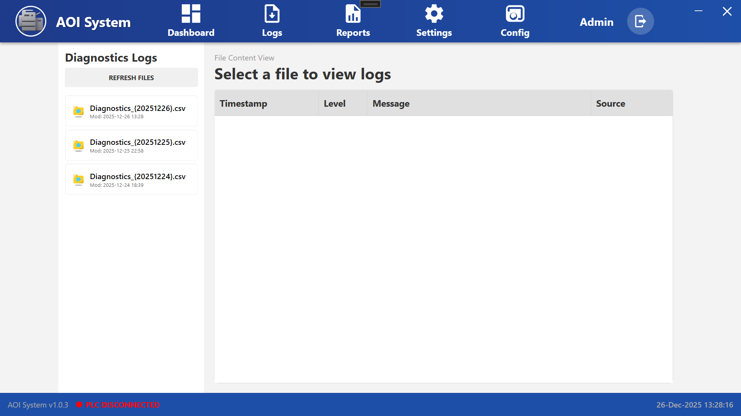

## 21.3 Navigation Flow

**Logs → Diagnostics Logs → Select Diagnostics File (.csv)**

After selecting a diagnostics log file, the system displays detailed diagnostic entries.

## 21.4 Screen Layout Overview

The Diagnostics Logs screen is divided into two main sections:

1. **File List Panel (Left Side)**
2. **Diagnostics Log Content View (Right Side)**

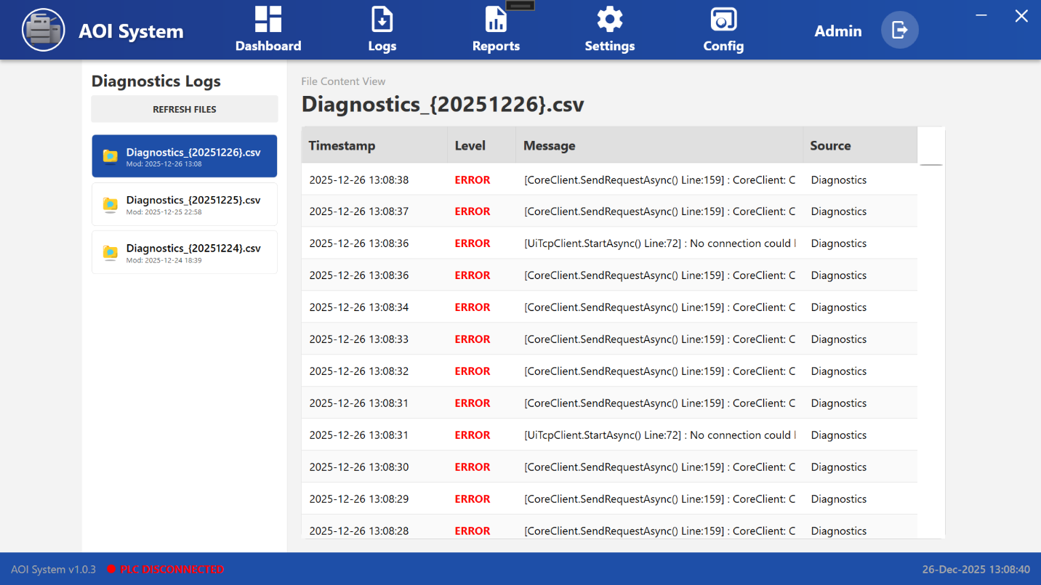

## 21.5 File List Panel

### **Available Options**

* **Refresh Files**  
  Reloads the list of available diagnostics log files.
* **Diagnostics Log Files**  
  Displays diagnostics log files with date-based names  
  (for example: Diagnostics_20251226.csv).

Each file shows:

* **Last Modified Date and Time**

## 21.6 Selecting a Diagnostics Log File

To view diagnostics details:

1. Click on a **Diagnostics_YYYYMMDD.csv** file from the left panel
2. The diagnostics entries are displayed in the right-side table

## 21.7 Diagnostics Log Content View

The diagnostics data is displayed in a table with the following columns:

* **Timestamp**  
  Date and time when the diagnostic event occurred.
* **Level**  
  Severity of the event (for example: **ERROR**).
* **Message**  
  Technical description of the issue  
  (for example: communication failure, request timeout, internal method error).
* **Source**  
  Indicates the system component generating the diagnostic message  
  (for example: Diagnostics, Core Client, TCP Client).

## 21.8 Operator Actions

From the Diagnostics Logs screen, the Operator can:

* Refresh diagnostics log file list
* Select and view diagnostics log files
* Observe repeated or continuous diagnostic errors
* Note timestamps and error messages

## 21.9 Operator Responsibilities

* **Do not attempt to fix technical errors directly**
* Note down:
  + Error message
  + Timestamp
  + File name
* Share diagnostics details with:
  + Maintenance team
  + Administrator
  + Technical support

## 21.10 Operator Limitations

* Operator cannot edit or delete diagnostics logs.
* Diagnostics logs are automatically generated.
* System-level fixes are handled by Admin or support team only.

## 21.11 Important Notes for Operator

* Continuous **ERROR** entries usually indicate:
  + PLC communication failure
  + Network or TCP connection issues
  + Internal service problems
* Always check **PLC connection status** at the bottom of the screen.
* Diagnostics Logs are critical for root cause analysis.

**22 Reports**

## 22.1 Screen Overview

The **Reports Screen** allows the operator to **view, generate, and export system reports** based on previously configured report formats.  
This screen is mainly used to analyze **production data, inspection results, uptime/downtime, and system performance** for a selected time period.

Reports generated from this screen help operators and supervisors review machine performance and production history.

## 22.2 Accessing Reports Screen

1. From the home screen, click on **Reports** in the top navigation bar.
2. The **Reports Screen** is displayed.

## 22.3 Screen Layout Description

The Reports screen consists of report selection controls at the top and a data display area below.

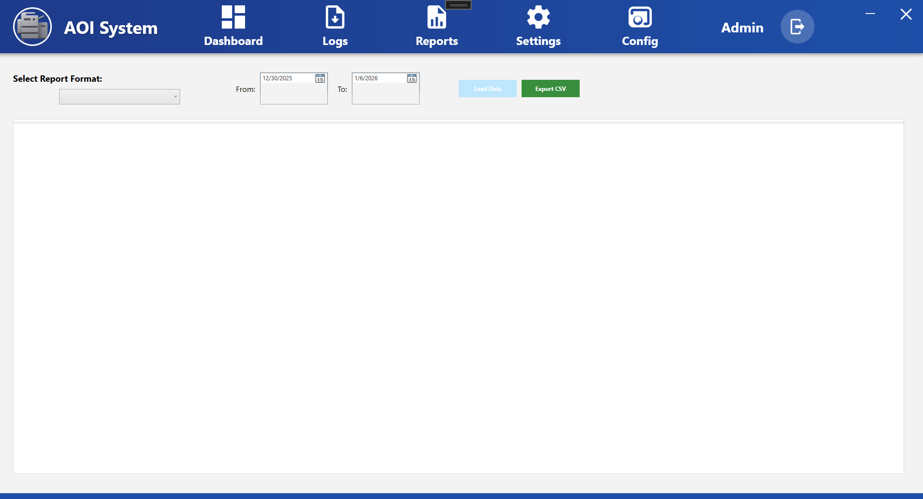

### **22.4 Report Selection Controls**

#### **Select Report Format**

* Dropdown used to select a report format.
* Formats listed here are created earlier in **Report Config**.

**Operator Use:**  
Select the required report format before loading data.

#### **Date Range Selection**

* **From** – Start date for the report
* **To** – End date for the report

**Operator Use:**  
Define the time range for which report data is required.

#### **Action Buttons**

* **Load Data**
  + Loads report data based on selected report format and date range.
* **Export CSV**
  + Exports the loaded report data into a CSV file.

### **Report Data Display Area**

* Displays the report data after clicking **Load Data**.
* Shows data columns as per the selected report format.
* If no data is available, the area remains empty.

## 22.5 Operator Actions

### **Generate Report**

1. Select a **Report Format** from the dropdown.
2. Select **From** and **To** dates.
3. Click **Load Data**.
4. Report data is displayed on the screen.

### **Export Report**

1. Load the report data.
2. Click **Export CSV**.
3. The report is saved as a CSV file for external use.

## 22.6 Operator Notes & Precautions

* Ensure correct report format is selected before loading data.
* Select appropriate date range to avoid missing or excessive data.
* CSV files can be opened using spreadsheet applications.
* Report generation does not affect live machine operation.
* If no data appears, verify report configuration or date range.

**23 Settings**

### **23.1 Screen Overview**

When the operator clicks on the **Settings** option from the top navigation bar, the **Settings Main Screen** is displayed.  
This screen provides access to important machine configuration and monitoring functions through a side menu available on the **left side of the screen**.

The main display area shows a background view of the AOI machine, indicating that the system is in Settings mode and waiting for the operator to select a specific function.

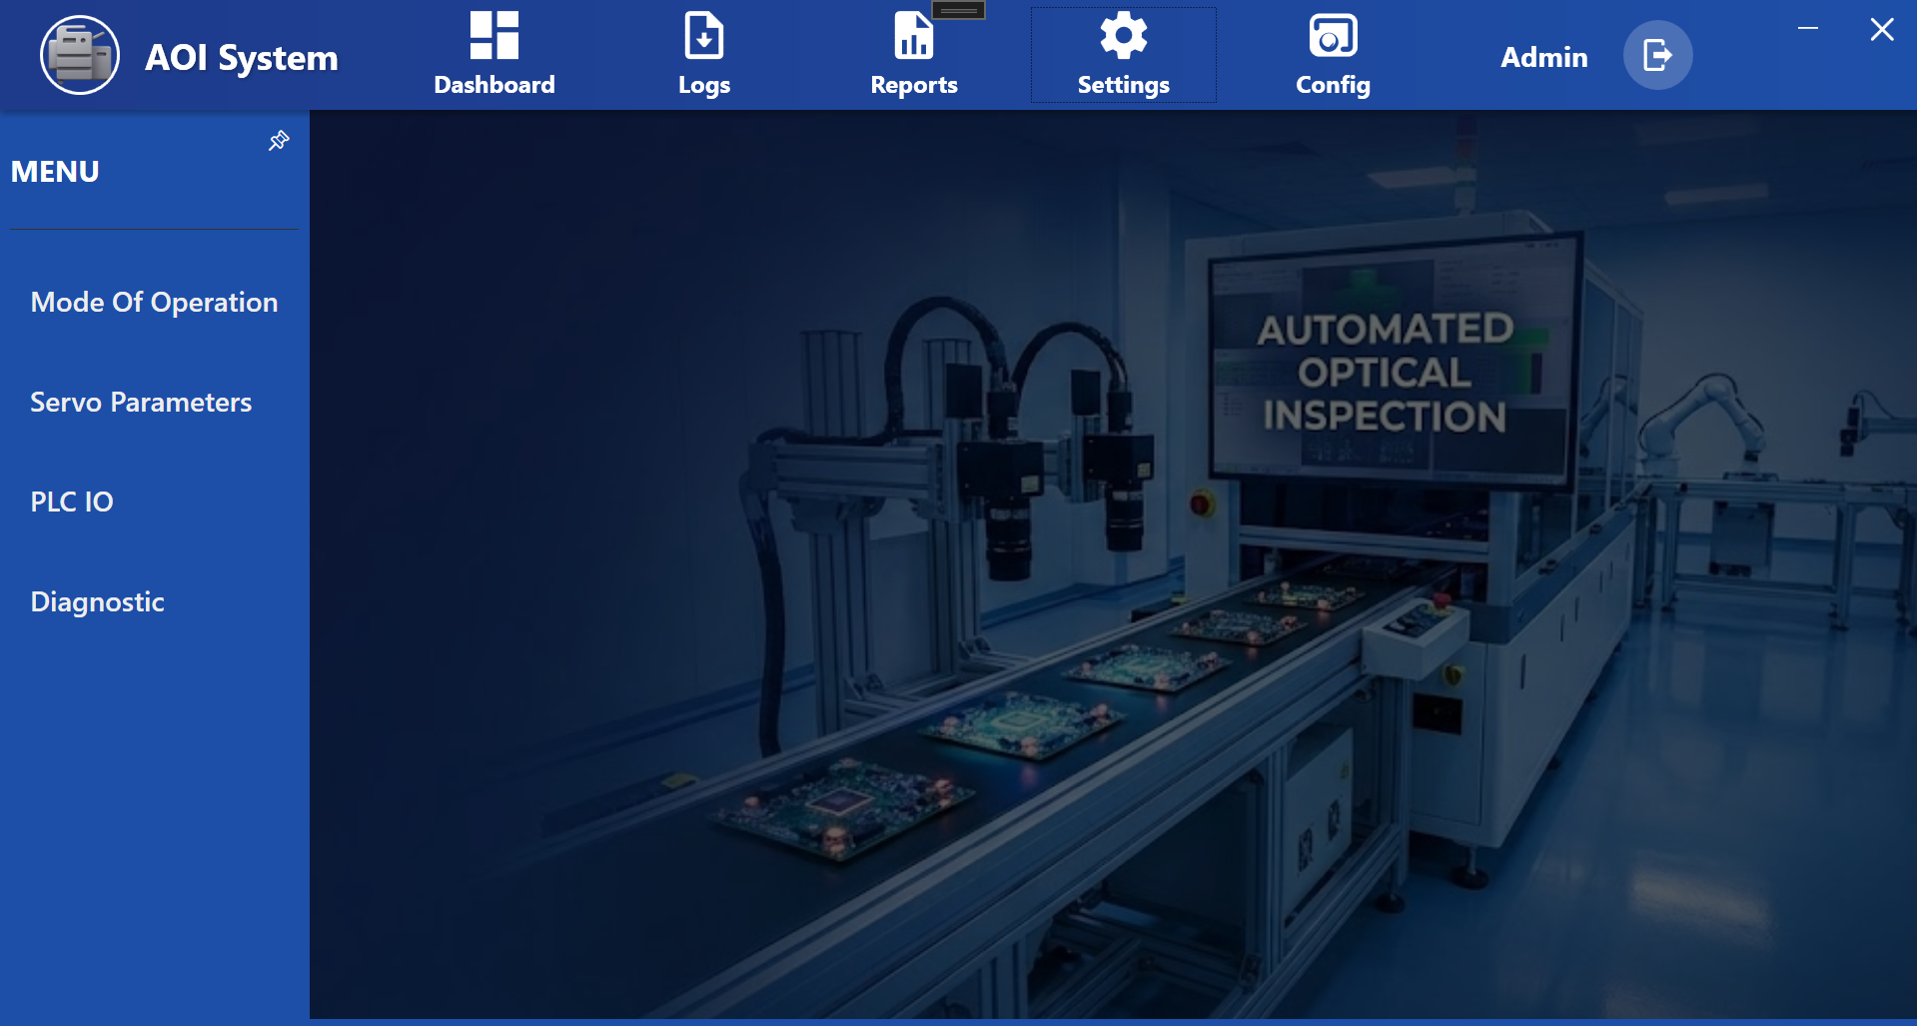

### **23.2 Screen Layout Description**

The Settings screen is divided into three main sections:

* Dashboard
* Logs
* Reports
* **Settings (Active)**
* Config
* Admin

The Settings icon is highlighted, indicating that the operator is currently inside the Settings section.

#### **22.3 Left Side Menu Panel (Settings Menu)**

A vertical side menu appears on the left side with the title **MENU**.  
This panel contains all available configuration and diagnostic options related to machine operation.

#### **22.4 Main Display Area**

The center and right portion of the screen displays a background image of the AOI inspection machine.  
Detailed parameter screens will appear in this area after selecting any option from the side menu.

### **22.5 Available Settings Menu Options**

The following options are available in the left side menu:

* **Mode of Operation**  
  Used to select or view the current working mode of the machine (e.g., Auto, Manual, etc.).
* **Servo Parameters**  
  Used to view and adjust motion-related parameters of servo motors.
* **PLC IO**  
  Displays real-time status of PLC input and output signals for monitoring machine communication.
* **Diagnostic**  
  Used for checking system health, alarms, and troubleshooting information.

### **22.6 Operator Actions**

* The operator must select one option from the left side menu to open the related detailed screen.
* After selection, the corresponding screen will be displayed in the main display area.
* Only one Settings function can be viewed at a time.

### **22.7 Operator Guidelines**

* Settings should be modified **only by authorized and trained operators or engineers**.
* Incorrect parameter changes may cause machine malfunction or inspection errors.
* If any abnormal behavior is observed, the operator should immediately inform the maintenance team.

**24 Mode of Operation**

**24.1 Screen Overview**

When the operator selects **Mode of Operation** from the **Settings** side menu, the Mode of Operation screen is displayed.  
This screen is used to control and select the operational mode of the AOI system.

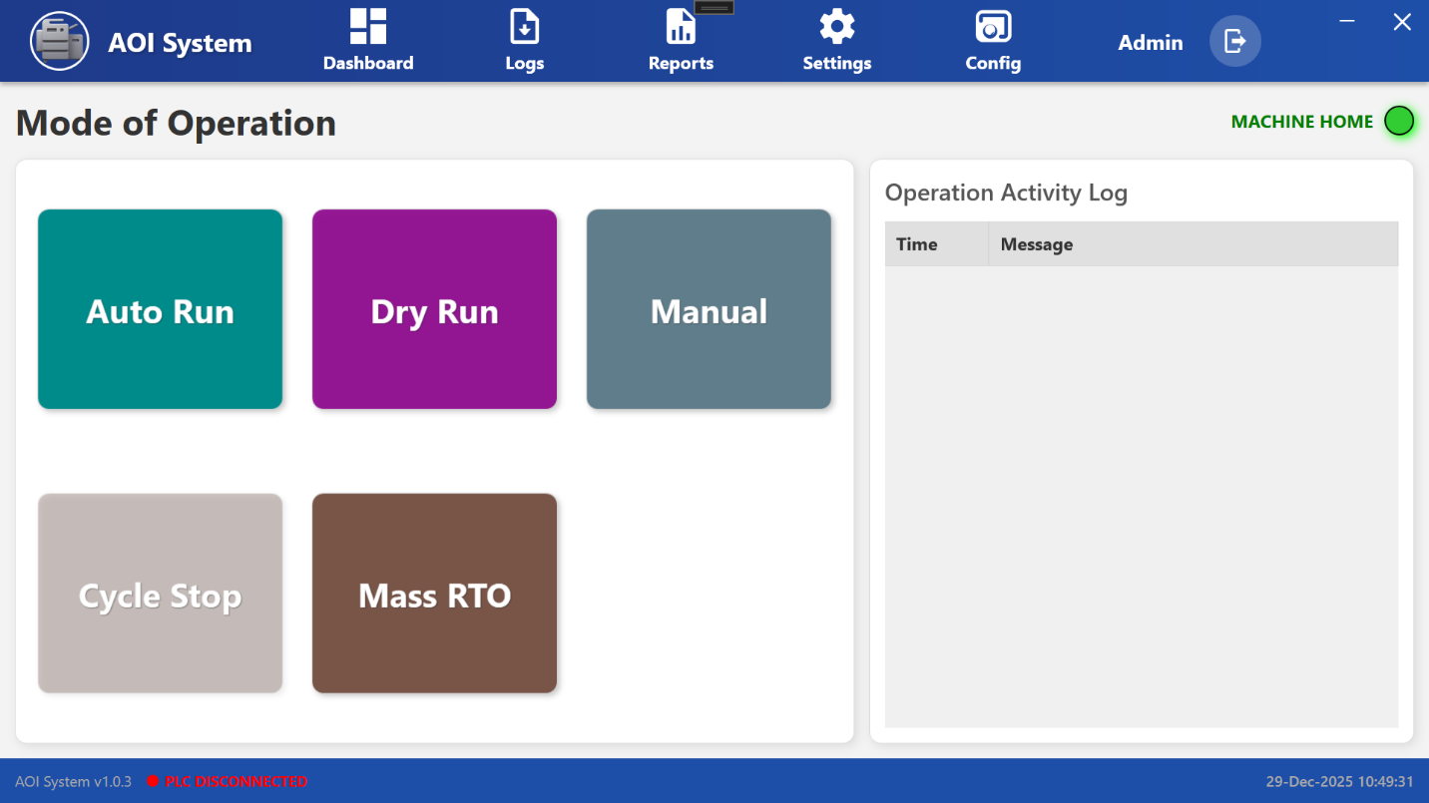

### **24.2 Available Operation Modes**

The following operation modes and controls are available on this screen:

#### **24.3 Auto Run**

* Used for fully automatic inspection operation.
* The machine runs continuously based on predefined inspection parameters.
* Recommended for normal production runs.

#### **24.4 Dry Run**

* Used to test machine movement without performing actual inspection.
* Helpful for setup verification, debugging, and maintenance checks.
* No inspection results are generated in this mode.

#### **24.5 Manual**

* Allows the operator to manually control machine functions.
* Used mainly for setup, calibration, and maintenance activities.
* Requires trained personnel to operate safely.

#### **24.6 Cycle Stop**

* Stops the machine operation after completing the current inspection cycle.
* Prevents sudden interruption during an active process.

#### **24.7 Mass RTO**

* Used to perform a mass Return to Origin (RTO) operation.
* All relevant machine axes move back to their reference/home position.

### **24.8 Operation Activity Log**

On the right side of the screen, the **Operation Activity Log** panel is displayed.

* Displays time-stamped operation messages and status updates.
* Helps operators track mode changes and system activities.
* Useful for troubleshooting and operation verification.

### **24.9 System Status Indicators**

* **Machine Home** indicator (green) shows that the machine is in home position and ready for operation.
* Bottom status bar displays system version, PLC connection status, and current date/time.

### **24.10 Operator Guidelines**

* Ensure the correct operation mode is selected before starting the machine.
* Use **Manual** and **Dry Run** modes only with proper training.
* Monitor the **Operation Activity Log** for confirmation of actions.
* If PLC is disconnected, do not start machine operation.

**25 Auto Run Mode Selection**

When the operator clicks on **Auto Run** in the Mode of Operation screen, the AOI system switches to **automatic operation mode**.

### **25.2 System Behavior After Selecting Auto Run**

* The **Auto Run** button becomes active, indicating that automatic mode has been selected.
* The system prepares to execute inspection cycles automatically based on the configured parameters.
* No manual intervention is required during normal operation.

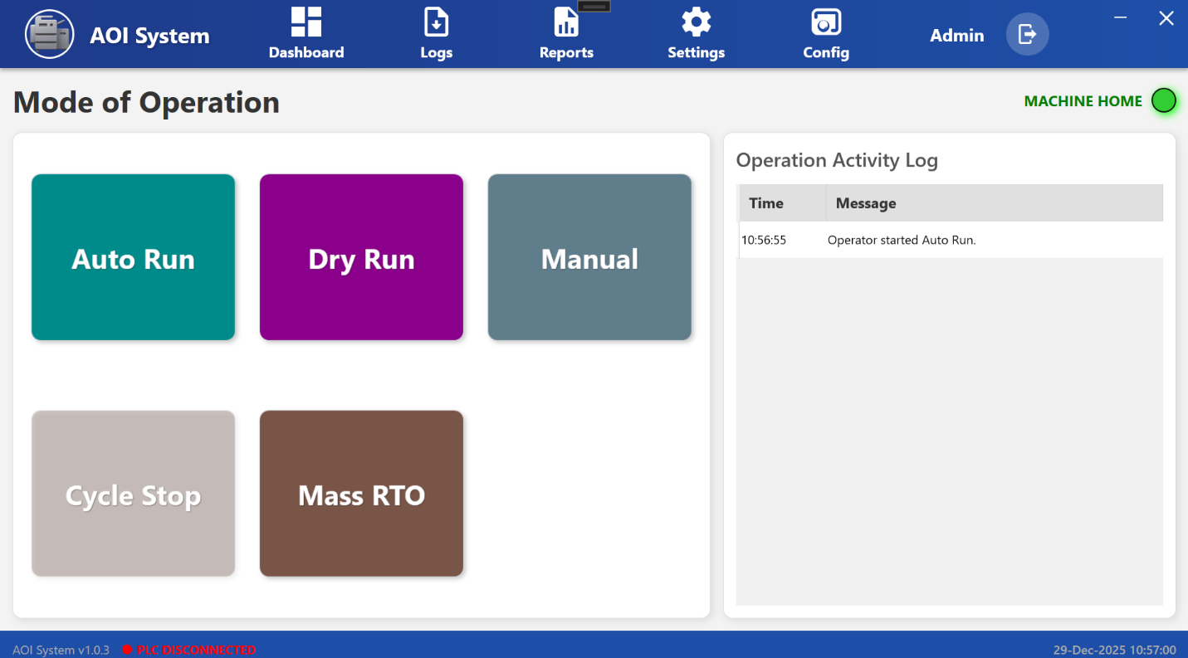

### **25.3 Operation Activity Log Update**

Once **Auto Run** is selected, an entry is recorded in the **Operation Activity Log** panel on the right side of the screen.

**Example log message:**

Operator started Auto Run.

This log entry includes:

* **Time** of the action
* **Message** describing the operation performed

The activity log helps in tracking operator actions and verifying system operations.

### **25.4 Machine Status Indication**

* The **Machine Home** indicator (green) confirms that the machine is in the home position and ready for operation.
* If the PLC connection is not available, the system status bar displays **PLC Disconnected**, and automatic operation should not be started.

### **25.5 Operator Guidelines**

* Ensure all safety checks and prerequisites are completed before selecting **Auto Run**.
* Verify PLC connectivity before starting automatic operation.
* Monitor the **Operation Activity Log** to confirm successful mode activation.
* In case of abnormal behavior, use **Cycle Stop** to safely stop the operation.

**26 Dry Run Mode Selection**

**26.1 Screen Overview**

When the operator clicks on **Dry Run** in the Mode of Operation screen, the AOI system switches to **Dry Run mode**.

### **26.2 System Behavior After Selecting Dry Run**

* The system enters **test operation mode** without performing actual inspection.
* Machine movements are executed based on configured paths and sequences.
* No inspection results or production data are generated in this mode.

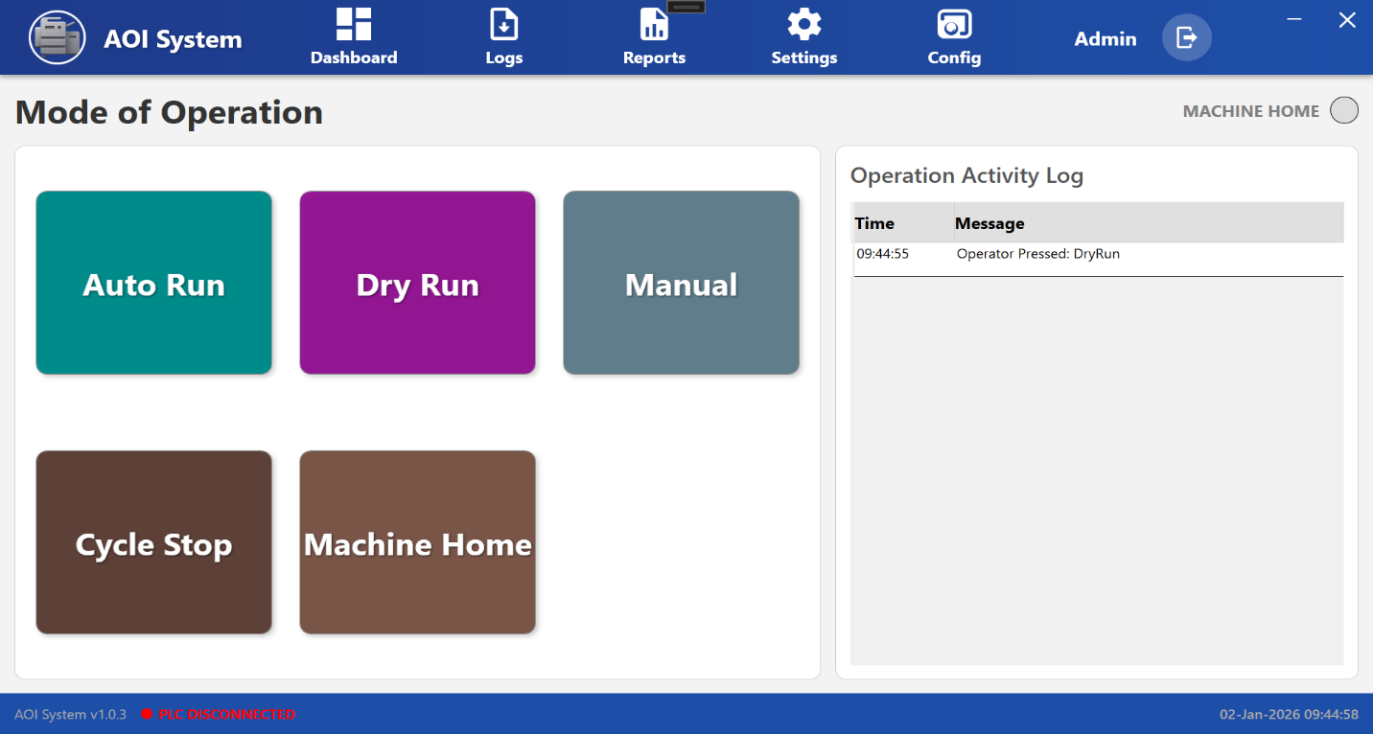

### **26.3 Operation Activity Log Update**

After selecting **Dry Run**, the system records the action in the **Operation Activity Log**.

**Example log message:**

Operator started Dry Run.

This log entry contains:

* **Time** when the mode was activated
* **Message** describing the operator action

The activity log ensures traceability of operational changes.

### **26.4 Typical Use Cases**

* Machine setup verification
* Motion path and sequence testing
* Maintenance and troubleshooting activities
* Operator training and validation

### **26.5 Operator Guidelines**

* Use **Dry Run** only after ensuring the work area is clear.
* Do not load production material during Dry Run.
* Monitor machine movement closely during test operation.
* Switch to **Auto Run** only after successful Dry Run verification.

**27 Manual Operation Screen**

## 27.1 Screen Overview

The **Manual Operation Screen** allows the operator to manually control individual machine movements and actuators.  
This screen is mainly used during **machine setup, adjustment, inspection, and maintenance** when automatic operation is not required.

All controls on this screen respond immediately to operator input, therefore movements must be performed carefully and under continuous observation.

## 27.2 Accessing Manual Operation Screen

1. Open the **Mode of Operation** screen.
2. Select **Manual**.
3. The system navigates to the **Manual Operation Screen**, displaying all available manual controls.

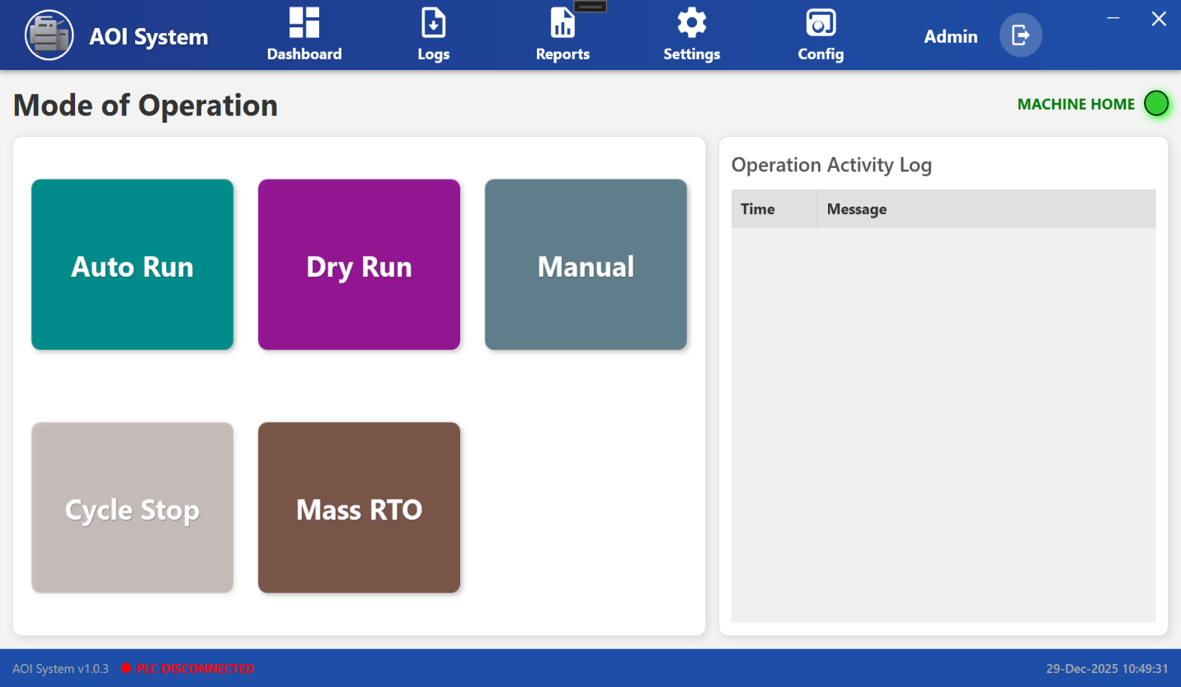

## 27.3 Screen Layout Description

The Manual Operation Screen is divided into clearly defined sections.  
Each section is designed to control a specific function of the machine.

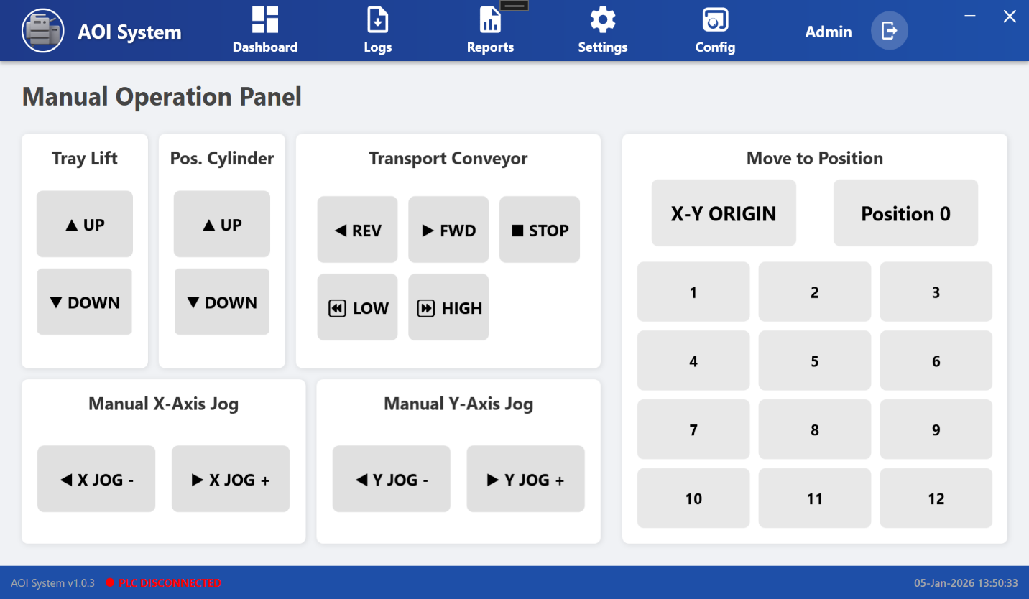

### **27.4 Tray Lift Section**

**Purpose:**  
Controls the vertical movement of the tray lift mechanism.

**Operator Controls:**

* **UP** – Moves the tray upward
* **DOWN** – Moves the tray downward

**Operator Use Case:**  
Used during tray loading, unloading, and height adjustment.

### **27.5 Positioning Cylinder Section**

**Purpose:**  
Controls the positioning cylinder used for component alignment or holding.

**Operator Controls:**

* **UP** – Extends the positioning cylinder
* **DOWN** – Retracts the positioning cylinder

**Operator Use Case:**  
Used to position components correctly during manual setup.

### **27.6 Transport Conveyor Section**

**Purpose:**  
Provides manual control over conveyor movement and speed.

**Operator Controls:**

* **REV** – Moves conveyor in reverse direction
* **FWD** – Moves conveyor in forward direction
* **STOP** – Stops conveyor immediately
* **LOW** – Sets low conveyor speed
* **HIGH** – Sets high conveyor speed

**Operator Use Case:**  
Used to manually move material during setup, inspection, or fault recovery.

### **27.7 Manual X-Axis Jog Section**

**Purpose:**  
Allows fine manual movement of the X-axis.

**Operator Controls:**

* **X JOG -** – Moves X-axis in negative direction
* **X JOG +** – Moves X-axis in positive direction

**Operator Use Case:**  
Used for precise alignment and calibration.

### **27.8 Manual Y-Axis Jog Section**

**Purpose:**  
Allows fine manual movement of the Y-axis.

**Operator Controls:**

* **Y JOG -** – Moves Y-axis in negative direction
* **Y JOG +** – Moves Y-axis in positive direction

**27.9 Operator Use Case:**  
Used for accurate positioning during inspection and setup.

### Move to Position Section

**Purpose:**  
Allows the operator to move the machine to predefined positions.

**27.8 Operator Controls:**

* **X-Y ORIGIN** – Moves machine to home position
* **Position 0** – Moves to reference position
* **Position 1 to 12** – Moves to stored preset positions

**Operator Use Case:**  
Helps in fast and repeatable positioning without manual jogging.

## 27.9 Operator Notes & Precautions

* Ensure the machine is in a safe state before performing manual movements.
* Always monitor axis movement while operating in manual mode.
* Do not use manual mode during active automatic cycles.
* Use emergency stop or STOP button immediately in case of abnormal behavior.

**28 Cycle Stop Screen**

## 28.1 Screen Overview

The **Cycle Stop** function allows the operator to safely stop the currently running machine cycle.  
When Cycle Stop is activated, the machine completes the ongoing safe step and then halts further operation.

This function is used when the operator needs to **pause production without abruptly stopping the machine**.

## 28.2 Accessing Cycle Stop

1. Navigate to the **Mode of Operation** screen.
2. Click on **Cycle Stop**.
3. The system immediately processes the cycle stop request and updates the machine status.

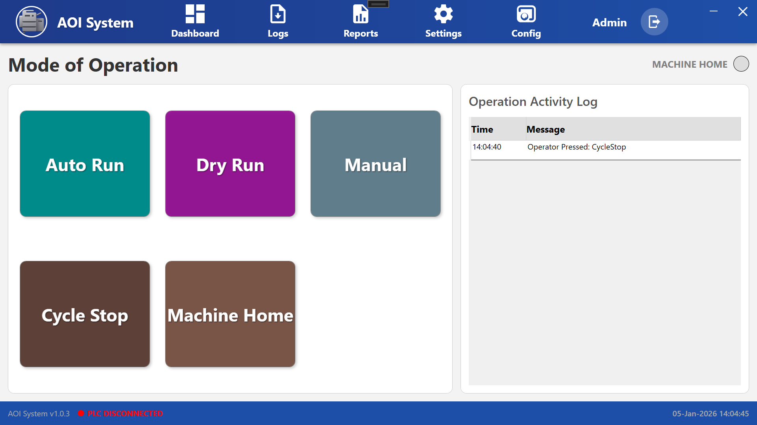

## 28.3 Screen Behavior After Cycle Stop

After the operator clicks **Cycle Stop**, the following behavior is observed:

* The machine stops executing the automatic cycle in a controlled manner.
* No new cycles are started.
* The **Machine Home indicator** changes status to show that the machine is no longer in active run state.
* The system remains powered and responsive for further operator actions.

## 28.4 Operation Activity Log Update

Once Cycle Stop is pressed, an entry is recorded in the **Operation Activity Log**.

**Example Log Entry:**

* **Time:** System timestamp
* **Message:** Operator Pressed: **CycleStop**

This log helps in tracking operator actions for audit and troubleshooting purposes.

## 28.5 Operator Actions After Cycle Stop

After the cycle is stopped, the operator can:

* Switch to **Manual Mode** for inspection or adjustment
* Perform **Machine Home** operation if required
* Resume operation by selecting **Auto Run** or **Dry Run** (as per process requirement)

## 28.6 Operator Notes & Precautions

* Cycle Stop should be used for **normal operational stopping** of the machine.
* Do not use Cycle Stop as an emergency stop.
* Always wait for machine motion to completely stop before opening guards or accessing machine components.
* Verify machine status before restarting the operation.

# **29 Machine Home Screen**

## 29.1 Screen Overview

The **Machine Home** function is used to move all machine axes and mechanisms to their predefined **home (reference) positions**.  
This operation ensures that the machine starts from a known and safe position before any automatic or manual operation.

Machine Home is typically performed:

* At the start of a shift
* After power ON or system restart
* After a Cycle Stop or fault recovery

## 29.2 Accessing Machine Home

1. Navigate to the **Mode of Operation** screen.
2. Click on **Machine Home**.
3. The system initiates the homing sequence for the machine.

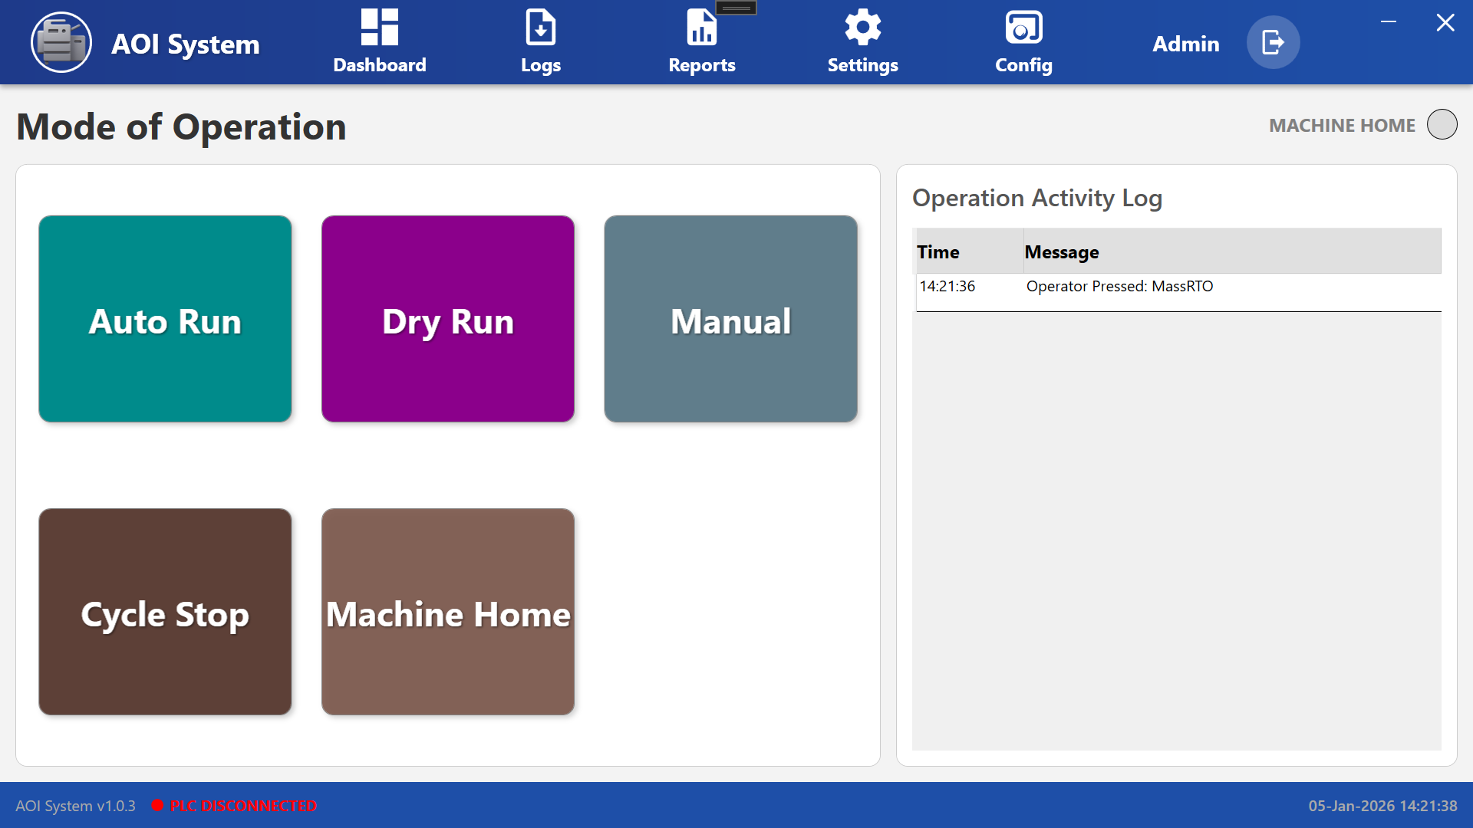

## 29.3 Screen Behavior After Machine Home Selection

Once **Machine Home** is selected, the following behavior is observed:

* The machine begins moving axes to their predefined home positions.
* All movements are executed in a controlled and sequential manner.
* During the homing process, operator input for other modes is restricted.
* The **Machine Home indicator** updates to reflect the homing status.

## 29.4 Operation Activity Log Update

When the operator presses **Machine Home**, an entry is recorded in the **Operation Activity Log**.

**Example Log Entry:**

* **Time:** System timestamp
* **Message:** Operator Pressed: MachineHome

This log entry helps in monitoring operator actions and system events.

## 29.5 Operator Actions During Machine Home

While the machine is performing the homing operation, the operator should:

* Observe all axis movements carefully.
* Ensure no obstructions are present in the machine working area.
* Avoid interacting with moving parts.
* Wait until the homing process is fully completed.

**29.6 Operator Actions After Machine Home Completion**

After successful homing, the operator can:

* Select **Auto Run** to start normal production
* Select **Dry Run** for testing without processing
* Switch to **Manual Mode** for adjustments or inspection

**29.7 Operator Notes & Precautions**

* Machine Home must be completed before starting **Auto Run**.
* Do not interrupt the homing process unless an unsafe condition is observed.
* If homing fails or stops abnormally, inform maintenance personnel.
* Ensure safety guards are properly closed before initiating Machine Home.

**30 Config (Configuration) Screen**

## 30.1 Screen Overview

The **Configuration (Config) Screen** allows authorized users to configure system-level settings required for proper operation of the AOI system.  
This screen provides access to multiple configuration modules such as logging, devices, alarms, users, PLC tags, and reports.

**Operator Note:**  
Configuration settings directly affect system behavior. Changes should be performed carefully and only as per instructions.

## 30.2 Accessing the Config Screen

1. From the top navigation bar, click on **Config**.
2. A **left-side configuration menu** appears on the screen.
3. Select the required configuration option from the menu.

## 30.3 Screen Layout Description

The Config screen is divided into two main areas:

* **Left Side Menu Panel**  
  Displays all available configuration categories.
* **Main Display Area**  
  Shows the selected configuration screen based on the menu option clicked.

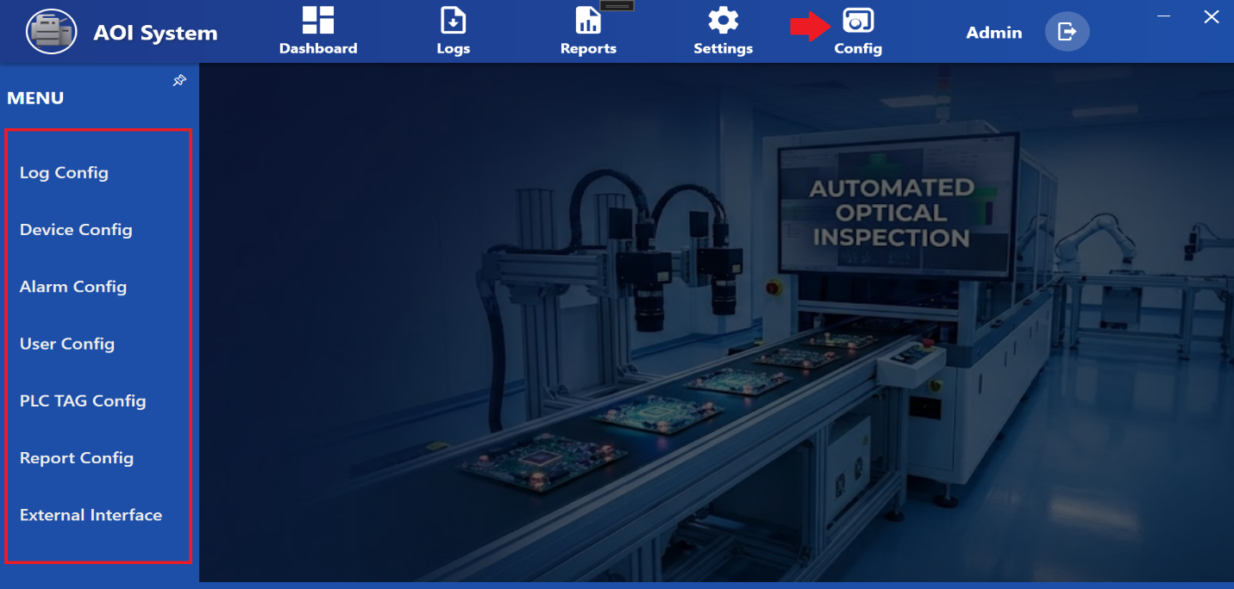

## 30.4 Configuration Menu Options

### **30.5 Log Config**

**Purpose:**  
Used to configure system logging behavior.

**Operator Use:**

* Enable or disable specific logs
* Adjust log levels for system monitoring and troubleshooting

### **30.6 Device Config**

**Purpose:**  
Used to configure connected devices such as cameras, sensors, or other hardware components.

**Operator Use:**

* Verify device connection status
* Update device-related parameters (as permitted)

### **30.7 Alarm Config**

**Purpose:**  
Used to manage system alarms and alerts.

**Operator Use:**

* View configured alarms
* Enable or disable alarms (as per authorization)
* Adjust alarm thresholds if required

### **30.8 User Config**

**Purpose:**  
Used to manage system users and access levels.

**Operator Use:**

* View user accounts
* Change passwords (if permitted)
* Assign roles as defined by system policy

### 

**Purpose:**  
Used to configure PLC communication tags.

**Operator Use:**

* Verify PLC tag mapping
* Check signal status for troubleshooting

Changes should be made only with proper knowledge.

### **30.9 Report Config**

**Purpose:**  
Used to configure report generation settings.

**Operator Use:**

* Select report formats
* Configure data fields for reports

### **30.10 External Interface**

**Purpose:**  
Used to configure communication with external systems.

**Operator Use:**

* Verify external interface settings
* Monitor data exchange configuration

## 30.5 Operator Notes And Precautions

* Only authorized users should access configuration screens.
* Incorrect configuration may lead to system malfunction.
* Do not modify parameters unless instructed by supervisor or maintenance team.
* Always verify system operation after making any configuration change.

**31 Log Configuration Screen**

## 31.1 Screen Overview

The **Log Configuration Screen** allows the operator to view and manage different system log categories generated by the AOI system.  
Logs are used to record system activities, production events, errors, and diagnostics for monitoring, troubleshooting, and audit purposes.

This screen displays a list of available log types along with their storage paths and auto-purge settings.

## 31.2 Accessing Log Configuration

1. Click on **Config** from the top navigation bar.
2. From the left-side menu, select **Log Config**.
3. The **List Log Configuration** screen is displayed.

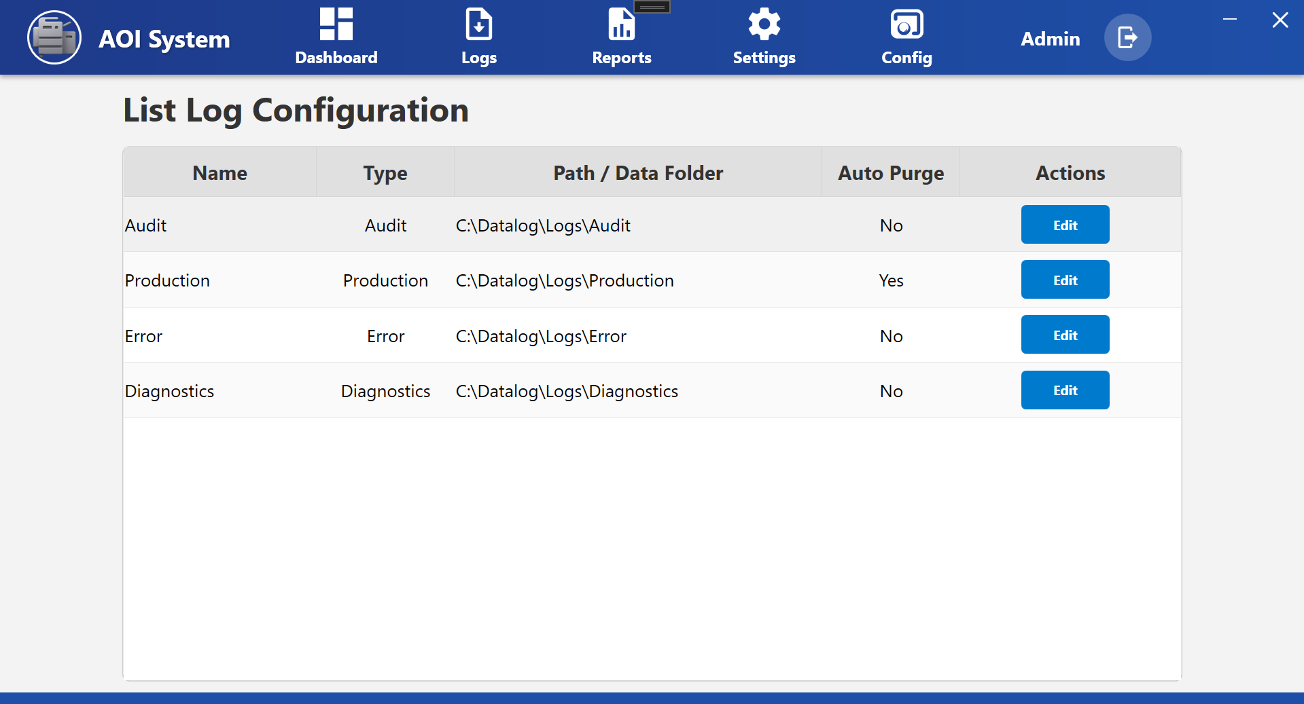

## 31.3 Screen Layout Description

The Log Configuration screen displays log details in a tabular format with the following columns:

* **Name** – Log category name
* **Type** – Type of log
* **Path / Data Folder** – File storage location
* **Auto Purge** – Indicates whether automatic log cleanup is enabled
* **Actions** – Edit option for the selected log

## 31.4 Available Log Types

### **Audit Log**

**Purpose:**  
Records operator actions and system-level events for traceability.

**Typical Usage:**  
Used for audits, compliance checks, and user activity tracking.

**Auto Purge:**  
Disabled by default.

### **31.5 Production Log**

**Purpose:**  
Records production-related data and process information.

**Typical Usage:**  
Used to analyze production performance and process flow.

**Auto Purge:**  
Enabled to automatically manage log size.

### **31.6 Error Log**

**Purpose:**  
Records system errors, faults, and abnormal conditions.

**Typical Usage:**  
Used by operators and maintenance teams for fault diagnosis.

**Auto Purge:**  
Disabled to retain error history.

### **31.7 Diagnostics Log**

**Purpose:**  
Records diagnostic and system health information.

**Typical Usage:**  
Used during troubleshooting and system analysis.

**Auto Purge:**  
Disabled by default.

## 31.8 Operator Actions

### Editing Log Configuration

1. Click the **Edit** button corresponding to the required log type.
2. Modify allowed parameters such as:
   * Log storage path
   * Auto purge setting (if permitted)
3. Save the changes.

Changes should be made only if authorized.

## 31.9 Operator Notes And Precautions

* Logs are critical for system monitoring and troubleshooting.
* Do not delete or modify log paths without proper authorization.
* Ensure sufficient disk space is available for log storage.
* Auto purge should be enabled only where recommended.

**32 Device Configuration Screen**

## 32.1 Screen Overview

The **Device Configuration Screen** allows the operator to view and manage hardware devices connected to the AOI system, such as PLCs and other control devices.  
This screen provides visibility into device details including type, make, model, and configuration status.

Device configuration ensures correct communication between the AOI software and connected hardware.

**Operator Note:**  
Device configuration should be handled carefully, as incorrect settings may affect machine operation.

## 32.2 Accessing Device Configuration

1. Click on **Config** from the top navigation bar.
2. From the left-side menu, select **Device Config**.
3. The **Device Configuration** screen is displayed.

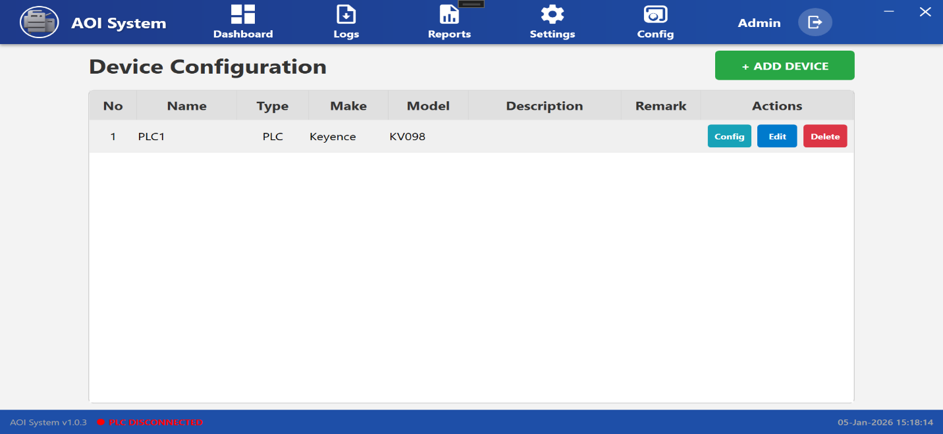

## 32.3 Screen Layout Description

The Device Configuration screen displays a list of configured devices in a table format along with action buttons.

### **Table Columns**

* **No** – Serial number of the device
* **Name** – Device name (e.g., PLC1)
* **Type** – Type of device (e.g., PLC)
* **Make** – Manufacturer of the device
* **Model** – Device model number
* **Description** – Additional device information
* **Remark** – Operator or system remarks
* **Actions** – Available actions for the device

## 32.4 Available Operator Actions

### **Add Device**

* Click **+ ADD DEVICE** to add a new device to the system.
* This option is generally used during initial setup or hardware replacement.

This action is typically restricted to authorized users.

### **Config**

* Click **Config** to configure communication parameters for the selected device.
* Used to set device-specific settings required for system communication.

### **Edit**

* Click **Edit** to modify device details such as name, description, or remarks.
* Use this option only when changes are required.

### **Delete**

* Click **Delete** to remove the selected device from the system.
* This action should be performed only if the device is no longer in use.
* Deleting an active device may cause system communication failure.

## 32.5 Operator Notes & Precautions

* Ensure the correct device is selected before performing any action.
* Do not modify PLC or device parameters without proper authorization.
* Verify device connection status after configuration changes.
* If PLC connection shows disconnected, inform maintenance personnel.

**33 Alarm Configuration Screen**

## 33.1 Screen Overview

The **Alarm Configuration Screen** allows the operator to view and manage all system alarms used in the AOI system.  
Alarms are generated when abnormal conditions, faults, or communication issues occur during machine operation.

This screen provides visibility into alarm details such as severity, PLC tag mapping, and alarm messages displayed to the operator.

**Operator Note:**  
Alarm configuration directly affects how faults are detected and displayed. Changes should be made only by authorized personnel.

## 33.2 Accessing Alarm Configuration

1. Click on **Config** from the top navigation bar.
2. From the left-side menu, select **Alarm Config**.
3. The **Alarm Configuration** screen is displayed with a list of configured alarms.

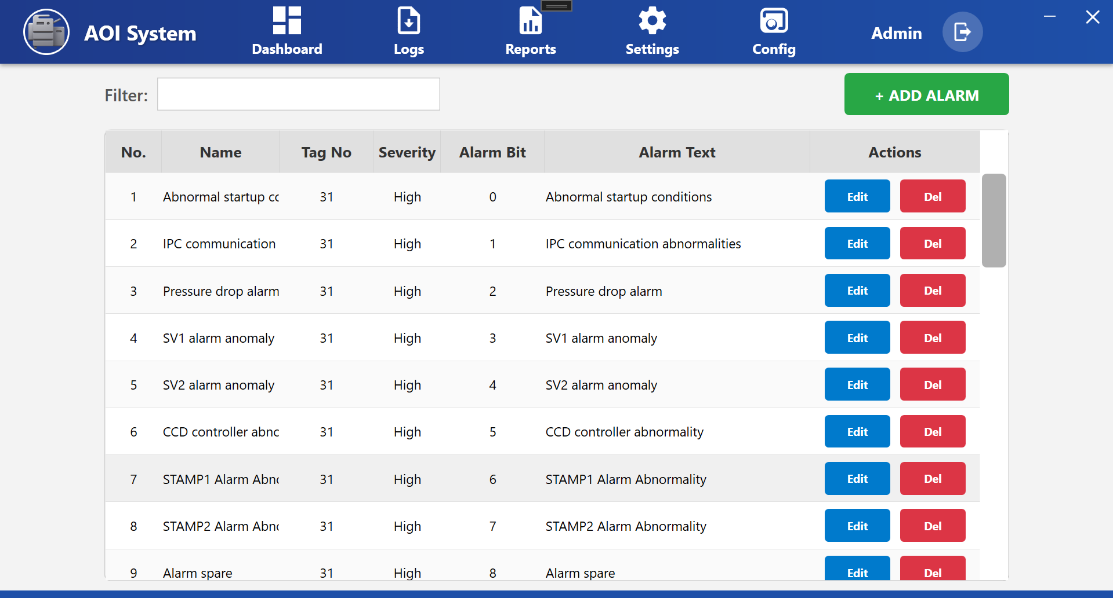

## 33.3 Screen Layout Description

The Alarm Configuration screen displays alarms in a tabular format along with control options.

### **Top Controls**

* **Filter** – Used to search alarms by name or keyword.
* **+ ADD ALARM** – Used to add a new alarm to the system (restricted access).

## 33.4 Alarm List Table Description

Each alarm entry contains the following information:

* **No.** – Serial number of the alarm
* **Name** – Alarm name displayed in the system
* **Tag No** – PLC tag number associated with the alarm
* **Severity** – Alarm priority level (e.g., High)
* **Alarm Bit** – PLC bit position used for alarm detection
* **Alarm Text** – Detailed message shown to the operator
* **Actions** – Options to edit or delete the alarm

## 33.5 Typical Alarm Examples (Operator View)

* **Abnormal startup condition** – Indicates incorrect startup sequence
* **IPC communication abnormalities** – IPC communication failure
* **Pressure drop alarm** – Air or pressure-related issue
* **SV alarm anomaly** – Solenoid valve malfunction
* **CCD controller abnormality** – Vision system controller fault
* **STAMP alarm abnormality** – Process or station-specific issue

These alarms help the operator quickly identify the source of the problem.

## 33.6 Operator Actions

### **View Alarm Details**

* Operators can view alarm names, severity, and alarm text for understanding the issue.

### **Edit Alarm**

* Click **Edit** to modify alarm details such as text or mapping.
* Typically performed by maintenance or admin users.

### **Delete Alarm**

* Click **Del** to remove an alarm from the system.
* This action should be avoided unless instructed.
* Removing alarms may result in missing fault indications.

## 33.7 Operator Notes And Precautions

* Do not modify alarm severity or PLC mapping without approval.
* Always read the **Alarm Text** carefully before taking corrective action.
* If repeated alarms occur, inform maintenance personnel.
* Ensure alarms are not disabled unintentionally.

**34 User Management Screen**

## 34.1 Screen Overview

The **User Management Screen** allows authorized personnel to view and manage users who can access the AOI system.  
This screen controls **user accounts, roles, and active status**, ensuring that only permitted users can operate or configure the system.

User management helps maintain **system security, accountability, and controlled access**.

**Operator Note:**  
User configuration affects system access. Any changes should be done only with proper authorization.

## 34.2 Accessing User Management

1. Click on **Config** from the top navigation bar.
2. From the left-side menu, select **User Config**.
3. The **User Management** screen is displayed.

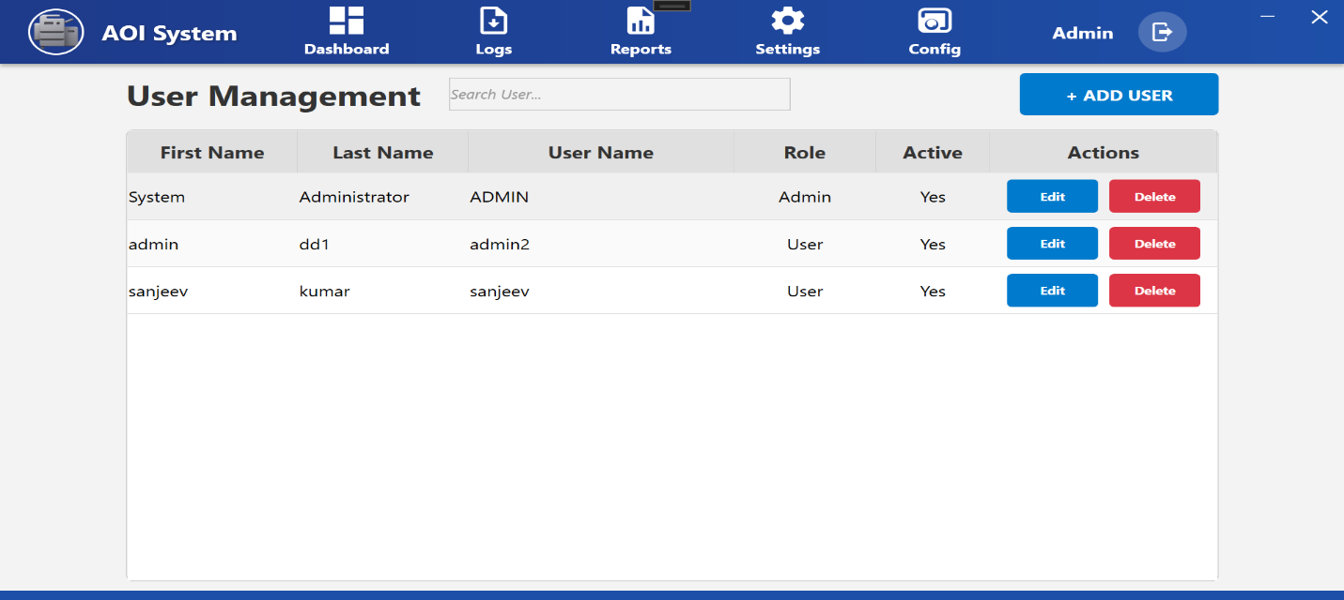

## 34.3 Screen Layout Description

The User Management screen consists of:

### **Top Controls**

* **Search User** – Used to search users by name or username.
* **+ ADD USER** – Used to create a new user account (restricted access).

### **User List Table**

Displays all configured users with their details and action buttons.

## 34.4 User List Table Description

Each user entry contains the following information:

* **First Name** – User’s first name
* **Last Name** – User’s last name
* **User Name** – Login username
* **Role** – Access level assigned to the user
  + Admin – Full system access
  + User – Limited operational access
* **Active** – Indicates whether the user account is enabled
* **Actions** – Options to edit or delete the user

## 34.5 Operator Actions

### **View Users**

* Operators can view the list of users and their assigned roles.
* Helps identify who has access to the system.

### **Add User**

* Click **+ ADD USER** to create a new user.
* Used when a new operator or admin needs system access.

This action is typically restricted to Admin users.

### **Edit User**

* Click **Edit** to modify user details such as name, role, or active status.
* Commonly used for role changes or updating user information.

### **Delete User**

* Click **Delete** to remove a user from the system.
* Used when a user no longer requires access.

Deleting an active or required user may restrict system operation.

## 34.6 Operator Notes & Precautions

* Do not share login credentials with others.
* Ensure each operator has a unique user account.
* Assign roles carefully based on job responsibility.
* Disable or delete users who no longer require access.
* Any unexpected login or access issue should be reported immediately.

**35 PLC Tag Configuration Screen**

## 35.1 Screen Overview

The **PLC Tag Configuration Screen** allows authorized users to view and manage PLC tags used for communication between the AOI software and the PLC.  
PLC tags define how data is read from or written to the PLC, including addresses, data length, and scaling logic.

This screen plays a critical role in **machine control, data acquisition, and alarm handling**.

**Operator Note:**  
PLC tag configuration directly affects machine behavior. Any incorrect change may cause communication failure or incorrect operation.

## 35.2 Accessing PLC Tag Configuration

1. Click on **Config** from the top navigation bar.
2. From the left-side menu, select **PLC TAG Config**.
3. The **PLC Tag Configuration** screen is displayed.

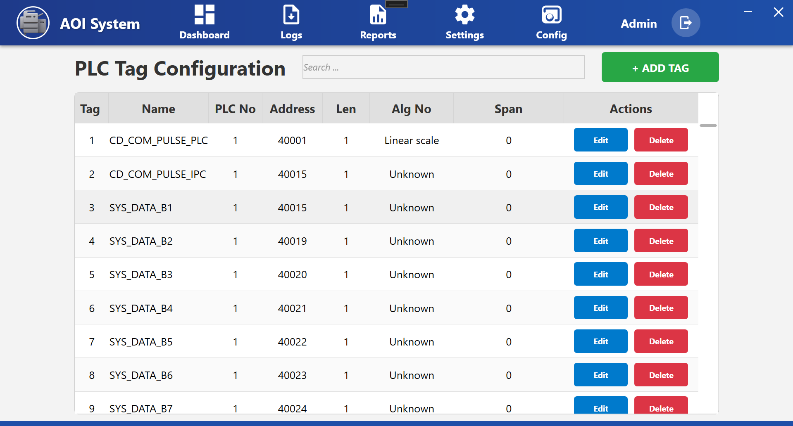

## 35.3 Screen Layout Description

The PLC Tag Configuration screen displays a list of configured PLC tags in a tabular format.

### **Top Controls**

* **Search** – Used to search PLC tags by name.
* **+ ADD TAG** – Used to add a new PLC tag (restricted access).

## 35.4 PLC Tag Table Description

Each PLC tag entry contains the following details:

* **Tag** – Serial number of the PLC tag
* **Name** – PLC tag name used by the system
* **PLC No** – PLC number to which the tag belongs
* **Address** – PLC memory address
* **Len** – Data length of the tag
* **Alg No** – Algorithm or scaling logic applied
  + Example: Linear scale, Unknown
* **Span** – Scaling or range value (if applicable)
* **Actions** – Options to edit or delete the PLC tag

## 35.5 Typical PLC Tag Usage (Operator View)

* **Communication Tags** – Used for handshake and status signals between IPC and PLC
* **System Data Tags** – Used for system states, control bits, and data exchange
* **Alarm Tags** – Used to trigger alarms based on PLC bit status

These tags allow the AOI system to monitor and control machine operation accurately.

**35.6 Operator Actions**

**View PLC Tags**

* Operators can view tag names, addresses, and PLC mapping for reference.
* Useful during troubleshooting with maintenance teams.

### **Add PLC Tag**

* Click **+ ADD TAG** to add a new PLC tag.
* Used during initial system setup or PLC program changes.
* This action should be performed only by trained and authorized personnel.

### **Edit PLC Tag**

* Click **Edit** to modify PLC tag parameters such as address, length, or algorithm.
* Used when PLC logic or addressing changes.

### **Delete PLC Tag**

* Click **Delete** to remove an unused PLC tag.
* Should be done only after confirming the tag is no longer required.
* Deleting an active PLC tag may cause system malfunction.

## 35.7 Operator Notes And Precautions

* Never change PLC addresses without confirmation from PLC program documentation.
* Always verify PLC communication after making tag changes.
* Do not modify algorithm or span values unless instructed.
* If PLC communication errors occur, inform maintenance immediately.
* Keep PLC tag configuration consistent with PLC logic.

# **36 Report Configuration Screen**

## 36.1 Screen Overview

The **Report Configuration Screen** allows the operator or authorized user to create, manage, and customize system reports.  
This screen is used to define **which data columns** should be included in reports generated by the AOI system.

Configured reports help in analyzing **production performance, inspection results, uptime, downtime, and process data**.

**Operator Note:**  
Report configuration controls report structure only. Actual report data is generated during system operation.

## 36.2 Accessing Report Configuration

1. Click on **Config** from the top navigation bar.
2. From the left-side menu, select **Report Config**.
3. The **Report Configuration** screen is displayed.

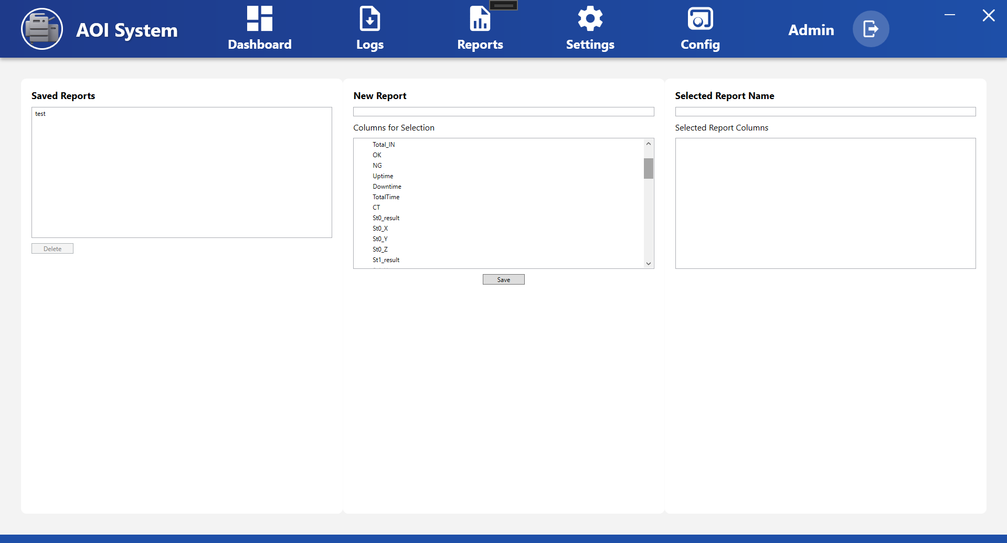

## 36.3 Screen Layout Description

The Report Configuration screen is divided into three main sections:

### **36.4 Saved Reports Section**

**Purpose:**  
Displays a list of previously saved report configurations.

**Details:**

* Shows saved report names.
* Allows selection of an existing report.
* **Delete** button is used to remove a selected report.

**Operator Use:**  
Used to manage and reuse previously defined report formats.

### **36.5 New Report Section**

**Purpose:**  
Used to create a new report configuration.

**Fields & Controls:**

* **New Report** – Enter the name of the new report.
* **Columns for Selection** – Displays all available data columns that can be included in the report.
  + Examples:
    - Total_IN
    - OK
    - NG
    - Uptime
    - Downtime
    - TotalTime
    - CT
    - Station result and axis data
* **Save** – Saves the new report configuration.

**Operator Use:**  
Select required columns based on reporting needs and save the report format.

### **36.6 Selected Report Section**

**Purpose:**  
Displays details of the currently selected report.

**Details:**

* **Selected Report Name** – Shows the selected report name.
* **Selected Report Columns** – Displays columns included in the selected report.

**Operator Use:**  
Used to verify report structure before generating reports.

## 36.7 Operator Actions

### **Create New Report**

1. Enter a report name in **New Report** field.
2. Select required columns from **Columns for Selection**.
3. Click **Save** to store the report configuration.

### **View Existing Report**

* Select a report from **Saved Reports**.
* View selected columns in **Selected Report Columns** section.

### **Delete Report**

* Select a report from **Saved Reports**.
* Click **Delete** to remove it.

Deleted report configurations cannot be recovered.

## 36.8 Operator Notes & Precautions

* Use clear and meaningful report names.
* Select only required columns to keep reports easy to understand.
* Do not delete reports that are regularly used without confirmation.
* Report configuration does not affect live machine operation.

**37 External Interface (Config Menu)**

## 37.1 Screen Overview

The **External Interface** screen is used to **configure and manage report formats** that will be used for exporting AOI System data to external systems.

This feature allows Operators to:

* Create customized report structures
* Select required inspection, production, and OEE data
* Prepare data formats for export from the Reports module

Although this option appears under the **Config menu**, it does **not affect machine operation or PLC control**.

## 37.2 User Role

* **User Type:** Operator
* Operators can access this screen to configure report formats
* No administrative permissions or machine settings are modified from this screen

## 37.3 Navigation Path

To open the External Interface screen, the Operator should follow this path:

**Top Menu → Config → External Interface**

After clicking **External Interface**, the report configuration screen is displayed.

## 37.4 Screen Overview

The External Interface screen is divided into **three main sections**:

### **37.5 Saved Reports**

This section displays all **previously saved report configurations**.

**Details:**

* Shows the list of saved report names
* Allows Operators to select and reuse existing report formats
* A **Delete** button is available to remove unwanted report configurations

### **37.6 New Report**

This section is used to **create a new report format**.

**Available Options:**

* **New Report Name Field**  
  Used to enter a unique name for the report format.
* **Columns for Selection**  
  Displays a list of available data fields, such as:
  + Timestamp
  + 2D Code
  + OEE
  + Availability
  + Performance
  + Quality
  + Total Input
  + OK / NG
  + Uptime
  + Downtime
  + Total Time

Operators can select one or more columns based on reporting requirements.

* **Save Button**  
  Saves the selected columns as a report format.

### **37.7 Selected Report Details**

This section displays:

* The **selected report name**
* The list of **columns included in the selected report**

This helps Operators verify the report configuration before using it for data loading or export.

## 37.8 Operator Actions

An Operator can perform the following actions on this screen:

1. View saved report configurations
2. Create a new report by selecting required data columns
3. Save report formats for future use
4. Delete unused or incorrect report configurations
5. Prepare report formats for use in the Reports screen

## 37.9 System Behavior

* Report configurations are stored in the system
* Saved reports can be reused multiple times
* Only selected columns are included during data export
* No real-time data modification is performed on this screen

## 37.10 Important Notes

* This screen is **only for report configuration**
* Actual data loading and export are performed from the **Reports menu**
* Creating or deleting report formats does not affect machine operation
* Operators should use clear and meaningful report names

## 37.11 Operator Responsibility

* Select only required columns to keep reports readable
* Avoid deleting report formats currently in use
* Use reports strictly for monitoring, analysis, and documentation
* Inform the system administrator if additional data fields are required